

**Blowing Bigger Bubbles to Get Kids Moving**

**Capstone Final Report**

Katie Henshaw, Matthew Mesman, Julie Yu

Industry Partners: Brendan McMorrow, Jack Miller

Faculty Advisor: Tarek Zohdi

MEng Capstone 2020-2021

# Executive Summary

This paper presents a new bubble toy designed to combat the increasing amount of time modern children spend staring at screens. In the past 10 years, the average amount of time young children spend on electronic devices has more than doubled and the COVID-19 pandemic has only increased screen time further. Our team has partnered with the toy company Move2Play to design interactive toys that encourage children to play with each other and the world around them. Move2Play is specifically aiming to enter the bubble toy market as it is one of the most popular toy markets on the Amazon storefront. Playing with bubbles has also been linked to children participating in more explorative and creative play, meaning that a bubble toy would perfectly fit Move2Play’s mission of inspiring active play. After analysing the market, we have identified an untapped niche - large bubbles. Most current bubble toys create bubbles with a few centimeters diameter, and Move2Play believes that blowing significantly larger bubbles will help differentiate their product from others on the storefront.

When approaching the design of our product the team used an iterative process of design. This process moved through three stages: sketch models, component optimization, and final production. The sketch model phase involved performing teardowns of competing products, rapid prototyping of potential concepts, and selection of a general design framework. Once a design was settled on, the team developed an adjustable prototype that allowed us to optimize the key dimensions and designs of our toy. The team examined the optimal bubble launch angle, fan design, nozzle dimensions, and wand design using both analytical and experimental methods to find specifications that met our design requirements. Finally, once all variables were solidified the team constructed a final prototype that was miniaturized to fit inside of a character chosen to appeal to the young age demographic of the toy.

Our prototype was analyzed using image processing and playtesting to validate our design and confirm that larger bubbles did increase kids’ enjoyment of the toy. When analyzing bubble size we found that our design’s bubbles had an average diameter of 8.7 cm in comparison to the 3.05 cm and 1.81 cm diameters produced by competing toys. Additionally, children remained engaged with our toy for ~25 minutes each play session compared to ~20 minutes with the competing toy. These results validate our design and confirm that we did not only surpass our metrics of success, but the toy is desirable to our target markets. (Katie et al.)

**Table of Contents**

**Executive Summary** **2**

**List of Figures** **4**

**List of Tables** **5**

**Business Analysis** **6**

Toy makers are missing out on an entire section of the bubble market. 6

Bubbles encourage active play among kids. 6

The bubble market is large and homogenous. 7

Selling on Amazon requires specific design priorities. 9

There is an untapped market for large bubbles. 10

**Technical Work** **12**

Technical requirements establish measurable metrics of success. 12

Bubbles are challenging to model due to their complexity. 13

Surface tension is key in describing the basics of bubble formation. 13

Bubble detachment is dependent on several principles. 14

Free Energy 14

Plateau-Rayleigh Instability 14

Force Imbalances Between Dynamic and Laplace Pressures 16

Bubble Color is dependant on the thickness of the film. 16

Developing the toy involved rapid prototyping and downselecting. 18

Optimizing the subcomponents of the machine ensured the largest bubbles. 21

Launch Angle 21

Fan Design 26

Air Nozzle 33

Wand Design 35

Results: Our bubbles are bigger than others. 38

Playtesting reveals that kids prefer our product. 40

Our toy is proven to meet our design requirements. 41

**Bibliography** **42**

# List of Figures

**Figure 1:** Teardown of components of Wistoyz bubble machine 8

**Figure 2:** Basic components of a bubble toy 12

**Figure 3:** Soap solution structure 13

**Figure 4:** Observations of Plateau-Rayleigh instability in our prototype experiments 15

**Figure 5:** Single vs. two-gas liquid interface 16

**Figure 6:** Light wave interference from reflected light causes colored light iridescence 17

**Figure 7:** Colors of a soap film based on wall thickness 17

**Figure 8:** Photo of our prototype generating bubbles 18

**Figure 9:** Three of the sketch models constructed by the team 19

**Figure 10:** Design solidified on after the sketch modeling stage of the design process 19

**Figure 11:** Our completely adjustable prototype with some of the replaceable components 20

**Figure 12:** The final optimized prototype 21

**Figure 13:** Free body diagram of bubble in air 22

**Figure 14:** Distance traveled in the x-direction vs. launch angle when $v_{f}=0$ m/s 24

**Figure 15:** Distance traveled in the x-direction vs. launch angle of varying wind directions 25

**Figure 16:** Relationship between static and dynamic pressure as the blade angle increases 27

**Figure 17:** Velocity vector components at the outer radius of the impeller 28  
**Figure 18:** Example of expansion angle increase due to boundary layer formation 29

**Figure 19:** Velocity profile accounting for boundary layer, old velocity profile in orange 29

**Figure 20:** Streamlines extending in a logarithmic spiral pattern 30

**Figure 21:** Volute parametric equations graphically represented 31

**Figure 22:** Isometric view of 3D modelled volute 32

**Figure 23:** A hotwire annonimeter was used to test the different 3D printed impellers 33

**Figure 24:** Dispersion angle depends on the Reynolds number of the flow 34

**Figure 25:** Fitted third order polynomial with inflection point at 50% of contraction length 35

**Figure 26:** The Solidworks model of one of the various test nozzles 35

**Figure 27:** Some of the wands designed and tested through this process 36

**Figure 28:** An example of bubble froth 37

**Figure 29:** The final Yin Yang wand 37

**Figure 30:** Histogram of the three bubble toys 38

**Figure 31:** Users testing our earliest prototype 40

# List of Tables

**Table 1:** Bubble toys selected for secondary competitive analysis 8

**Table 2:** Simulation parameters 24

**Table 3:** Maximum distance traveled in the x-direction for varying varying wind directions 26  
**Table 4:** Impeller testing data 32

**Table 5:** Means and standard deviations for all three bubble toys 39

# Business Analysis

### Toy makers are missing out on an entire section of the bubble market.

Bubbles inspire children to question the world around them. The seemingly magical way they float through the air reflecting rainbows has encouraged active play and creative thinking since the 18th century [1]. Move2Play, a small toy company focused on encouraging active play, hopes to encapsulate the enthralling nature of bubbles to get kids off the couch, outside and moving. In this paper our team presents the novel bubble machine that has resulted from our partnership with Move2Play. Specifically, we have identified an unmet need within the bubble market - large bubbles. Through market research and competitive analysis we have found that most toys that claim to create large bubbles either require human input or simply fail to consistently produce bubbles. We seek to fill this niche by utilizing fluid dynamic principles and rapid prototyping to design a toy that both functions well and can perform well on Amazon, Move2Play’s primary storefront. We hope by creating a well engineered toy we will inspire children to engage with bubbles in new fun ways, improving their childhood learning experience. (Katie et al.)

### Bubbles encourage active play among kids.

In our increasingly modernised world children have more access to screen entertainment than ever. While screens are quickly becoming a staple of modern living, research suggests that the increased viewing of screen entertainment can lead to many psychological and physical ailments for developing adolescents. This includes poor self-regulation which is expressed by pre-school aged children as an inability to suppress behavioural and attentional impulses. Increased screen time is also linked to poor socioemotional skills in toddlers and prevents them from learning how to calm themselves down when they are upset [2]. All of these skills are vital for children; however screens serve to inhibit these aspects of their development.

The amount of time children are spending using screens has increased dramatically. From 1997 to 2014 screen time has more than doubled for 0–2-year-olds and increased significantly for 3–5-year-olds [3]. This is concerning as the long-term effects of increased screen time during early childhood development can not yet be studied accurately. Increased screen time has already been linked to decreased academic performance and mental health outcomes in adolescents [4]. This indicates that excessive screen usage will most likely cause negative health outcomes for today’s young children, the first generation who have never seen a world without screens.

Electronic screen entertainment often outcompetes traditional play due to its increased ability to engage the senses. Move2Play, this project’s sponsor, endeavours to challenge this assumption by creating physical toys that are as engaging as screens and encourage kids to engage in active play patterns. They want to help get kids off the couch by creating seemingly magical toys that inspire creativity of movement [4].

Bubbles have enthralled kids since they were first sold as a toy in the 1940s. The magical way bubbles float on invisible micro air currents consistently surprises and instills wonder in children. This experience of awe and uncertainty has been linked to an increase in childhood explorative play [6]. Children who are awestruck by things like bubbles develop an awareness of the knowledge gap in their perception of how the world works [7]. This awareness has been strongly linked to the ability to use novel approaches in the face of uncertainty [6], meaning that children who experience awe engage in more explorative and creative play, which may increase time spent playing in general.

We all know how children express this explorative and creative play with bubbles. Kids love to chase and pop bubbles, to jump for them when they are out of reach, to test how bubbles work in creative and active ways. Therefore our goal has been to engineer new methods of creating bubbles that will inspire awe in children and encourage them to play in active ways. (Matthew)

### The bubble market is large and homogenous.

In addition to the positive impacts of bubbles among children, there are also economic advantages for entering this sector of the toy market. The bubble sector of the toy market is quite large in terms of potential sales and customers. On the e-commerce platform, Amazon, the projected yearly revenue was estimated at US $22 million from Move2Play’s market research on Helium10 - a site with data analytics for selling on Amazon [8]. This estimation takes into account monthly sales of 120 bubble-related toy products currently listed on Amazon. From Helium10, we also obtained the search volume of associated keywords for bubble toys. For toys listed with the keyword “bubble machine” the projected monthly search volume was 173,637 searches, which conveys the popularity of these toys among consumers [8]. The substantial yearly revenue and search volume on Amazon indicate that further growth in market size outside of the e-commerce site is likely.

Following our initial market research, we conducted competitive analysis on several bubble toys. We focused on popular products and products with varying bubble-making mechanisms. This analysis focused on several components: qualitative observations of toy function and play demo, documentation of included parts such as batteries and bubble solution, and teardowns of each product. Teardowns consisted of deconstructing each toy to gain insight on bubble mechanisms and key manufactured parts. Table 1 notes the different products selected and their associated characteristics.

**Table 1:** Bubble toys selected for secondary competitive analysis

| Bubble Toy | Toy Image |
| --- | --- |
| WisToyz’s Animal Bubble Machine |  |
| WisToyz’s Bubble Blaster |  |
| Bubble Gun |  |
| Alex Toys’ Monster Bubbles |  |



Move2Play’s market research pointed us towards first analyzing WisToyz’s animal bubble machine, which generated revenues more than US $143,000 for the month of February 2021 [8]. With 4.3 stars from 12,522 ratings on Amazon, this product was clearly both popular and well-liked by consumers [9]. The toy came with a bottle of bubble solution and a screwdriver; two AA batteries were required but not provided. This provided a good baseline for expected bubble toy power requirements and recommendations for additional commercial goods to include with the toy. Like many of the other advertised bubble toys on Amazon, the product produced successful automated streams of small bubbles with diameters of roughly 20mm. Figure 1 shows the teardown of the toy, where inner components include a motor-fan assembly, wand, trough, and a two part outer animal character shell. Again, from teardowns of other similarly marketed products, this schematic appeared to be the standard for most bubble toys.

Other products such as the bubble gun, monster bubbles, and bubble blaster were selected because of their differentiated bubble-making mechanisms and advertised bubble sizes. The inner components of the toys are very similar to WisToyz’s animal bubble machine. However, these toys did not have an automated mechanism for bubble production. For example the bubble gun required pressing down on a trigger to create bubbles, while Alex Toys’ monster bubble machine required turning a bubble wand handle. Furthermore, the toys advertised for larger bubbles such as Alex Toys’ monster bubble machine and WisToyz’s bubble blaster both functioned poorly in creating streams of large bubbles. In the case for the monster bubble machine, there was only one successful trial detaching one large bubble (roughly 150mm) out of 20 trials.

Our secondary competitive analysis revealed that many of the well selling toys were similar to each other in terms of structural components and function. They were both automated and produced continuous streams of small bubbles. In contrast, while other toys attempted to advertise the novelty of larger bubbles the execution of functions were poor and manual. Consequently, this research highlighted an opportunity within the market to introduce a bubble toy that was capable of automating streams of large bubbles reliably. (Julie)

### Selling on Amazon requires specific design priorities.

Move2Play currently sells the majority of its products through their Amazon marketplace, a strategy followed by most small toy companies. With 22 milliondollars spent on bubble toys on Amazon annually, it can be difficult for new products to make headway into this flooded market. Luckily, through their experience on the platform Move2Play has identified key design principles that are specific to success on the site. While these strategies are hard to quantify or empirically prove, our team focused on applying Move2Play’s industry knowledge into our toy design.

When looking at an Amazon store page, the first thing a potential customer will see is the product's photos. The decision to purchase a product on Amazon differs from that of a box retailer. In the case of a box retailer, the consumer can physically hold the box and sees the packaging - they may even be able to see and hold the actual toy before they make their purchase. In the case of Amazon, the consumer is limited to any photographs or videos the seller posts, before they make their purchase. As such, the seller can control the framing of the product to increase sales. The WisToyz bubble machine we examined during our teardown, for example, seems to be quite large on its Amazon listing. However when received we discovered that it was no taller than a typical pen. This deceptive marketing regarding the size is intentionally to increase sales while minimizing costs. While our team is not seeking to deceive potential buyers, keeping this focus on scale in mind is still important when designing our toy. As one of our product’s key features is its large bubbles, we need a way to show the bubble size digitally. As such, we focused on designing our mechanism to be as small as possible. This way, when presented digitally, the bubbles will seem significantly large in proportion to the toy. This will then help highlight our product’s niche and ideally attract more purchasers.

Beyond the visual presentation of the product, the primary way that users can learn about the toy before purchase is through reviews. These reviews, found at the bottom of every product's Amazon page, allow purchasers to rank the product from 1 to 5 stars and leave comments about their experience with the product. These reviews are critical to a product's success. Reviews often snowball where positive reviews on the site lead to more product sales which then lead back to more positive reviews. This then catapults a product into the best sellers lists and Amazon is then more likely to recommend it to others on the site. While this situation is the ideal for products on Amazon, studies have shown a negativity bias in regards to customer reviews [10]. Essentially, negative reviews have a stronger impact on purchasing decisions than positive reviews. This means that combating negative reviews is actually more important than securing positive reviews. With this negativity bias in mind our team decided to examine current reviews for bubble toys to see what features commonly result in bad reviews. By examining the 1-3 star reviews of the top selling bubble toys we discovered that the primary causes of negative reviews included the toy leaking fluid and the toys failing to make bubbles after a few minutes of use. This process is what led to addition of a 10 minute run time design requirement for our new product. We also made tradeoffs throughout the design process to maximize consistency of bubble production, potentially at the expense of peak performance. Ultimately Amazon’s reviews can be the make or break of a product's success, and designing to ensure positive and minimize negative reviews is a concept that our team kept in mind through the process.

Ultimately, designing a toy for Amazon requires engineers not only to consider the physical realities of the toy, but also to consider the business behind the storefront. There are many more aspects to selling on Amazon that our team considered through our design process, from the animal character we chose to maximize search results to the pricing of our toy to be competitive on the marketplace. In this paper we chose to highlight the scaling and reviews as they are the least expected design challenges that we faced as a team. Designing a physical product for digital sales is a challenge of balancing factors like price, presentation, and quality, a challenge that our team constantly considers from the toys initial concept to the final prototype. (Katie)

### There is an untapped market for large bubbles.

In retrospect, we discovered that introducing bubble toys to children may strongly encourage them to partake in active play and reduce their daily screen time. In doing so, we focused on entering this sector of the toy market as the size of the market offers opportunities for new products to enter. Through further research on competing products, we concluded that there was an unmet need for automating large bubbles, which our bubble machine meets. Additionally, our machine would also incorporate Amazon selling strategies as this e-commerce platform would be the most optimal route for a small toy company like Move2Play to enter the market. While our product has not been tested on the market, we are confident through our assumptions and research that a toy capable of producing large bubbles will attract many consumers. (Julie et al.)

# Technical Work

## Technical requirements establish measurable metrics of success.

In order to design a bubble toy we had to understand the main components of similar toys. In essence, all bubble toys have the same components. A fan pressurizes air into a fluid flow, which exits via a nozzle. We will refer to this fluid flow as an air jet in this paper. This air jet interacts with a film of soap solution, which is suspended in a wand usually made of injection-molded plastic. The air jet extends the soap film, creating a bubble that detaches from the wand. The wand then submerges in a trough full of soap solution and eventually emerges with the soap film replaced, ready to create more bubbles.

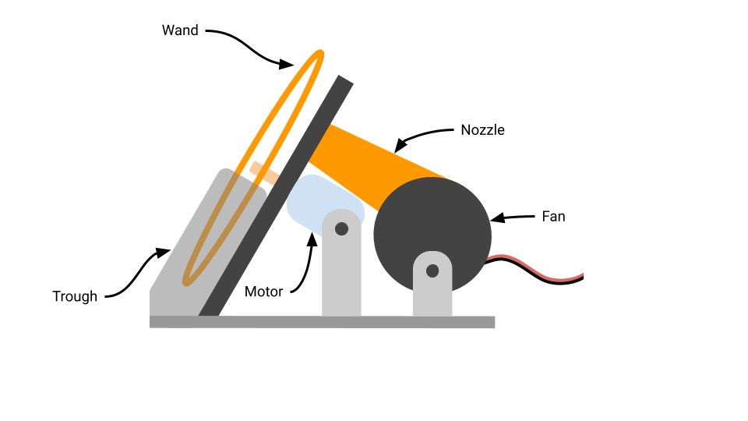

**Figure 2:** Basic components of a bubble toy

Based on what we observed from our competitor analysis and what we know about children we determined requirements for our product to be successful. These requirements are:

* Bubble diameter greater than 7.5 cm
* Distance bubbles travel unassisted by wind greater than 1 meter.
* Operating time of at least 10 minutes without refilling.
* Maximum 3 AA batteries required to power the toy.
* Small enough to fit in the standard Amazon toy package.
* Works impressively and consistently. (Matt)

## Bubbles are challenging to model due to their complexity.

### Surface tension is key in describing the basics of bubble formation.

Before designing a robust bubble toy, we needed to first understand the principles behind soap bubbles. From a high level, surface tension is the primary phenomenon responsible for bubble formation. The soap solution used to create bubbles for toys consists of two components: water and a surfactant [11]. Water alone experiences high surface tension compared to other liquids; this can be attributed to the attraction between water ($H_{2}O$) molecules. Specifically, at the surface of the liquid, stronger bonds occur between molecules as there are fewer ones available, resulting in high surface tension [11]. In the case of soap solution, the introduction of a surfactant weakens the surface tension within the liquid, allowing bubbles to form. Surfactants consist of a hydrophilic head and a hydrophobic tail. While the hydrophilic head is attracted to water molecules within the solution, the hydrophobic tail repels itself. These interactions result in an arrangement where surfactant molecules rest at the surface of the solution, where the hydrophobic tail can avoid water molecules [11]. This arrangement weakens the cohesive forces between water molecules at the surface of the solution, which ultimately reduces surface tension. (Julie)

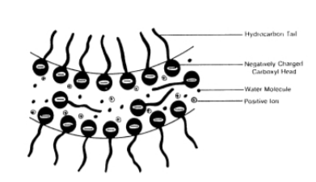

**Figure 3:** Soap solution structure [12]

### Bubble detachment is dependent on several principles.

##### Free Energy

The concept of free energy explains the nature of a bubble’s spherical shape.soap solution is “under constant tension due to surface tensions” [11]. As such we can utilize this phenomenon to analyze free energy. Free energy is defined as: 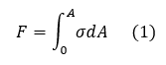

where 𝜎 is the surface tension of the solution and dA is the area of a small segment on the soap film. Assuming that surface tensions is constant with a large concentration of surfactant, we can integrate equation one and simplify to the following [11]:

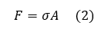

From the relationship in equation 2, it is evident that free energy is directly proportional to surface area. Consequently, to minimize free energy, surface area must also decrease. During the process of bubble detachment, there is a balance of the forces from an air jet enlarging the size of a bubble and the solution’s surface tension counteracting to minimize free energy. At some point, the surface tension will cause the bubble to pinch off and form a spherical shape, as that shape results in the minimum surface area for a closed bubble and simultaneously achieves minimum free energy [11]. (Julie + Matt)

##### Plateau-Rayleigh Instability

The Plateau-Rayleigh instability describes droplets of water forming from one singular cylindrical flow of fluid. From our prototype experiments, we noticed that this behavior also occurs in bubble detachment (see Figure 4). We observed a stream of bubbles forming from a column of cylindrical soap film.

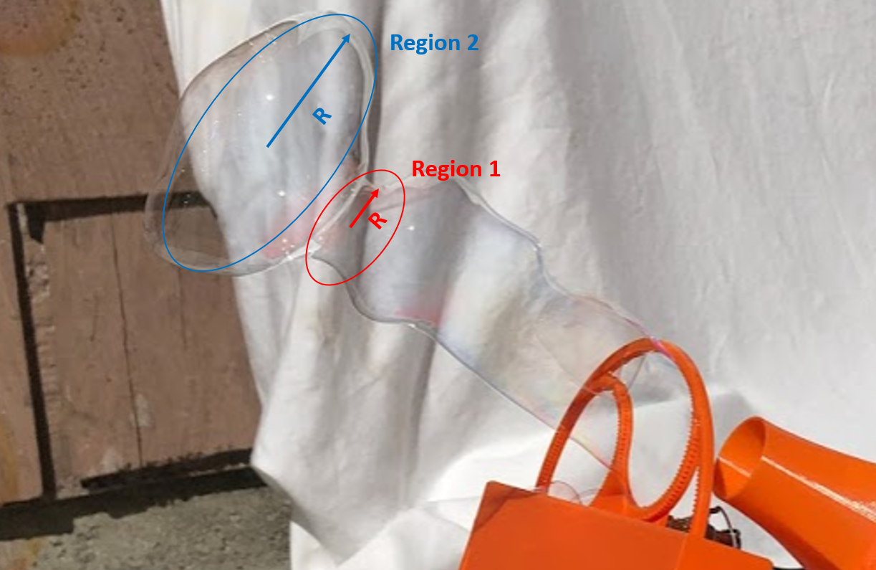

**Figure 4:** Observations of Plateau-Rayleigh instability in our prototype experiments

As mentioned previously, the presence of surface tension causes the film to reach lower energy states. In this behavior, lower energy states are achieved when closed bubbles are formed as they exhibit less surface area compared to the soap film column. To illustrate this we can apply the conservation of volume in the following relationship:

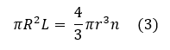

where R is the radius of the column, r is the radius of the detached closed bubble (droplet), L is the length of the column, and n is the number of resultant bubbles (droplets) [11]. By solving for n in equation 3 we can compare the surface area, $S_{0}$, of the column to the total surface area of the bubbles (droplets), $S_{n}$, through:

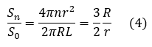

From equation 4, less surface area is achieved through detached closed bubbles (droplets) when r > $\frac{3}{2}$ R [11], [13]. For our prototype, the film column radius was measured to be R = 3.76 m and our detached closed bubbles were estimated to be r = 8.7 m, satisfying the relationship in equation 4.

Furthermore, to understand the rupture point within the column of soap film, we can introduce the Young - Laplace equation, which is defined as the following equation:

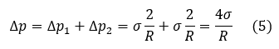

for a soap bubble with a two gas-liquid interface (see Figure 5) where $Δp$ is the pressure difference [11]. Using equation 5 to understand the pressure gradient exhibited under the Plateau-Rayleigh instability, the pressure gradient increases when the radius of column (R) increases from in region 1 from region 2 (see Figure 4). In doing so, there is also a higher momentum flux where there is higher momentum from high pressure to low pressure regions, causing a rupture within the column and resultant bubbles (droplets) [14]. (Julie + Matt)

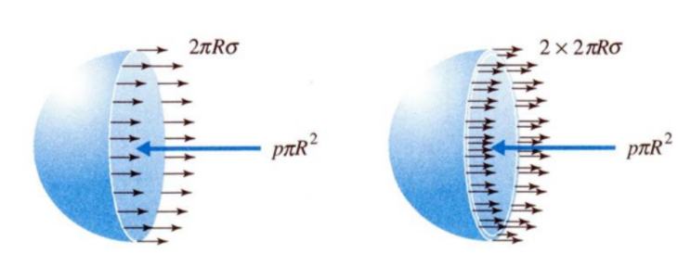

**Figure 5:** Single vs. two-gas liquid interface [15]

##### Force Imbalances Between Dynamic and Laplace Pressures

The expansion of a soap film to create a bubble occurs via a force imbalance between the dynamic pressure created by the gas jet and the Laplace pressure of the extended bubble film due to surface tension. The relationship between dynamic pressure and laplace pressure is represented as the following:

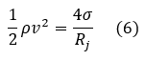

where $v$ is the velocity of flow, $ρ$ is the air pressure, $σ$ is the surface tension coefficient of the film, and $R_{j}$ is the jet radius [16].

In this scenario, a hemispherical cavity is formed with a radius equal to the jet radius. If the dynamic pressure is greater than the Laplace pressure a bubble will grow and eventually detach. In the case of our toy we had no real way to calculate the surface tension of the bubble soap solution that we used. We therefore did not theoretically calculate the critical velocity of bubble detachment. Our goal was not to calculate the exact velocity at which a bubble will detach, instead we wanted to find a trade off between velocity of the bubble at detachment and expansion of the bubble film to maximize the size of each bubble. (Julie + Matt)

### Bubble Color is dependent on the thickness of the film.

We noticed that our bubbles seemed to be more colorful than the competition. This led us to investigate what causes a bubbles iridescent color. The different iridescent colors that can be seen on a bubble are dependent on the wall thickness of said bubble. As the wall thickness decreases from the normal range, more vibrant colors can be seen. As the film thickness changes, the reflected light interacts constructively and destructively, changing the wavelength of the resultant light wave. This results in different colors of light being reflected off the bubble and observed.

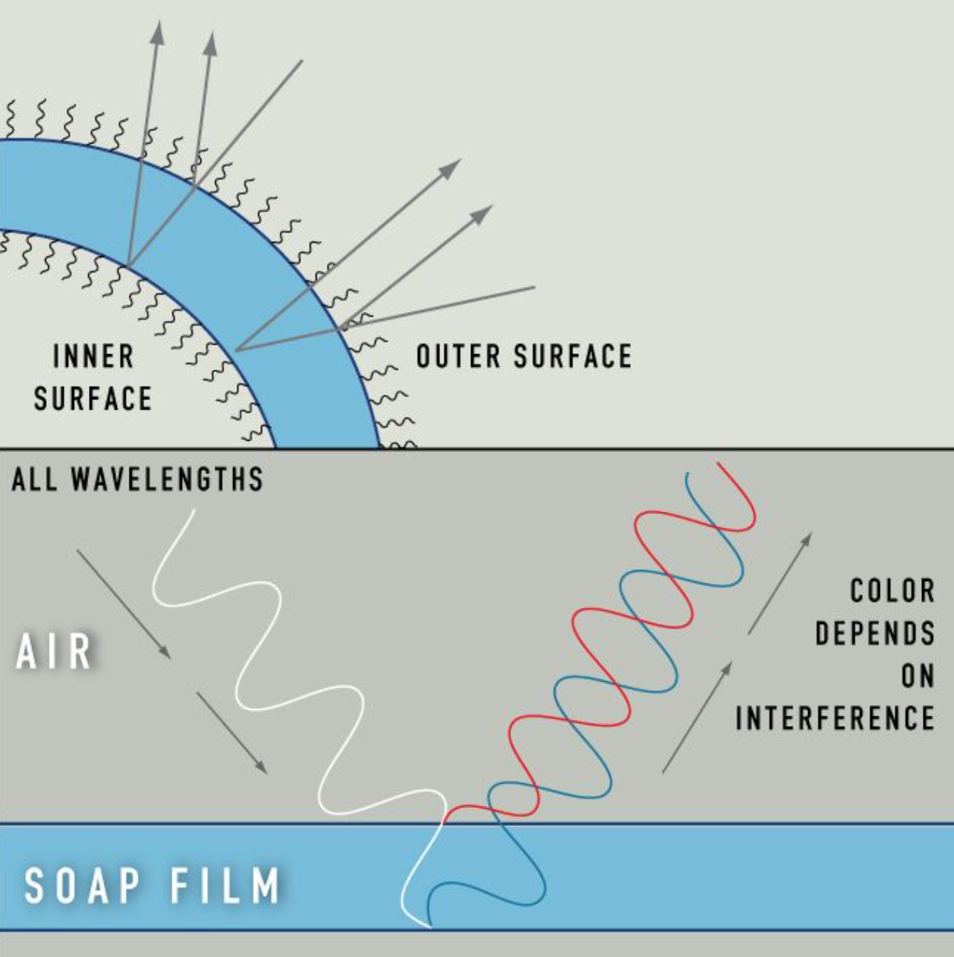

**Figure 6:** Light wave interference from reflected light causes colored light iridescence [16]

When examining photos of our bubble toy in function, a blue ring can be seen reflected off of the bubble. This indicates that our bubbles are most likely in the range of 400-500 nm thick.

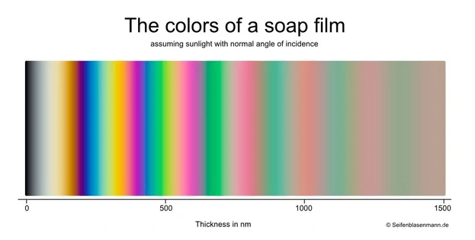

**Figure 7:** Colors of a soap film based on wall thickness [17]

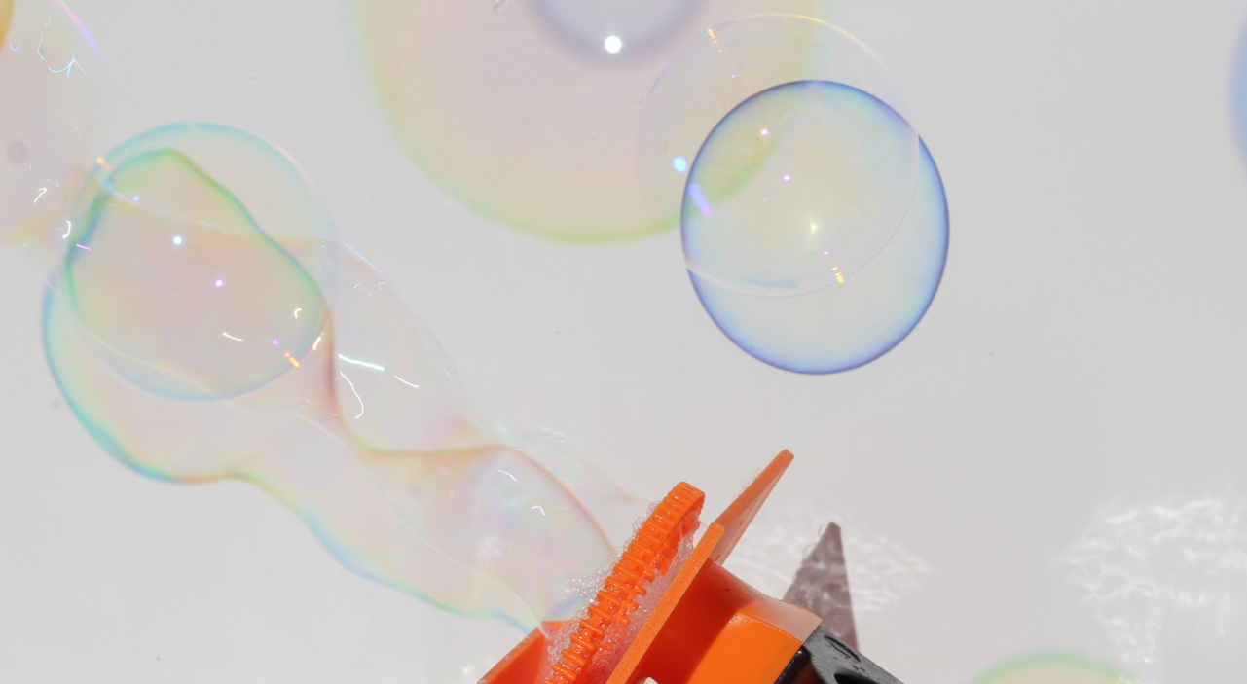

**Figure 8:** Photo of our prototype generating bubbles; the vibrant blue light indicates 400-500 nm film thickness

This is also the band of most vibrant color which gives our bubbles an attractive appearance. The color is determined on the type of solution used to create bubbles [16], [17]. Therefore we believe that the larger bubbles produced by our toy are more colorful simply because they are larger making them easier to see.

## Developing the toy involved rapid prototyping and downselecting.

The process for designing our product had three distinct phases, all focused on quickly validating our designs. Our “fail faster” methodology allowed us to conceptualize, test, and iterate on ideas without wasting development time on ideas that later proved to be infeasible. This process of prototyping and down selecting from a wide range of ideas and possible solutions was critical to our team’s fast-moving process.

The first phase of our product’s development was focused on creating low-fidelity prototypes of a wide range of potential concepts. At the beginning of the fall semester, after performing physical teardowns of competing products, each team member generated at least three potential mechanisms that could theoretically achieve the design goal of blowing large bubbles. The team then used dot voting to select three concepts that were then constructed using cardboard, rope, wire, and other materials that were easy to acquire. These early prototypes were built within a day and tested over a single weekend.

|  |  |  |
| --- | --- | --- |
| **(a)** | **(b)** | **(c)** |

**Figure 9:** Three of the sketch models constructed by the team: (a) A vertically rotating design, (b) a string and weight based system, and (c) a barrel drum style design.

While none of these concepts worked flawlessly, it was quickly apparent that some were stronger candidates than others. For example, the team expected the barrel drum style (c) mechanism to work well due to its bubble wand’s large size. However, after prototyping the mechanism, we saw that the air flow was disrupted by the rear of the drum, thus invalidating the entire concept. Through this process we eventually settled on a simple vertically rotating mechanism for our design as seen in Figure 10. We selected this mechanism due to its manufacturability, small size, and number of parts.

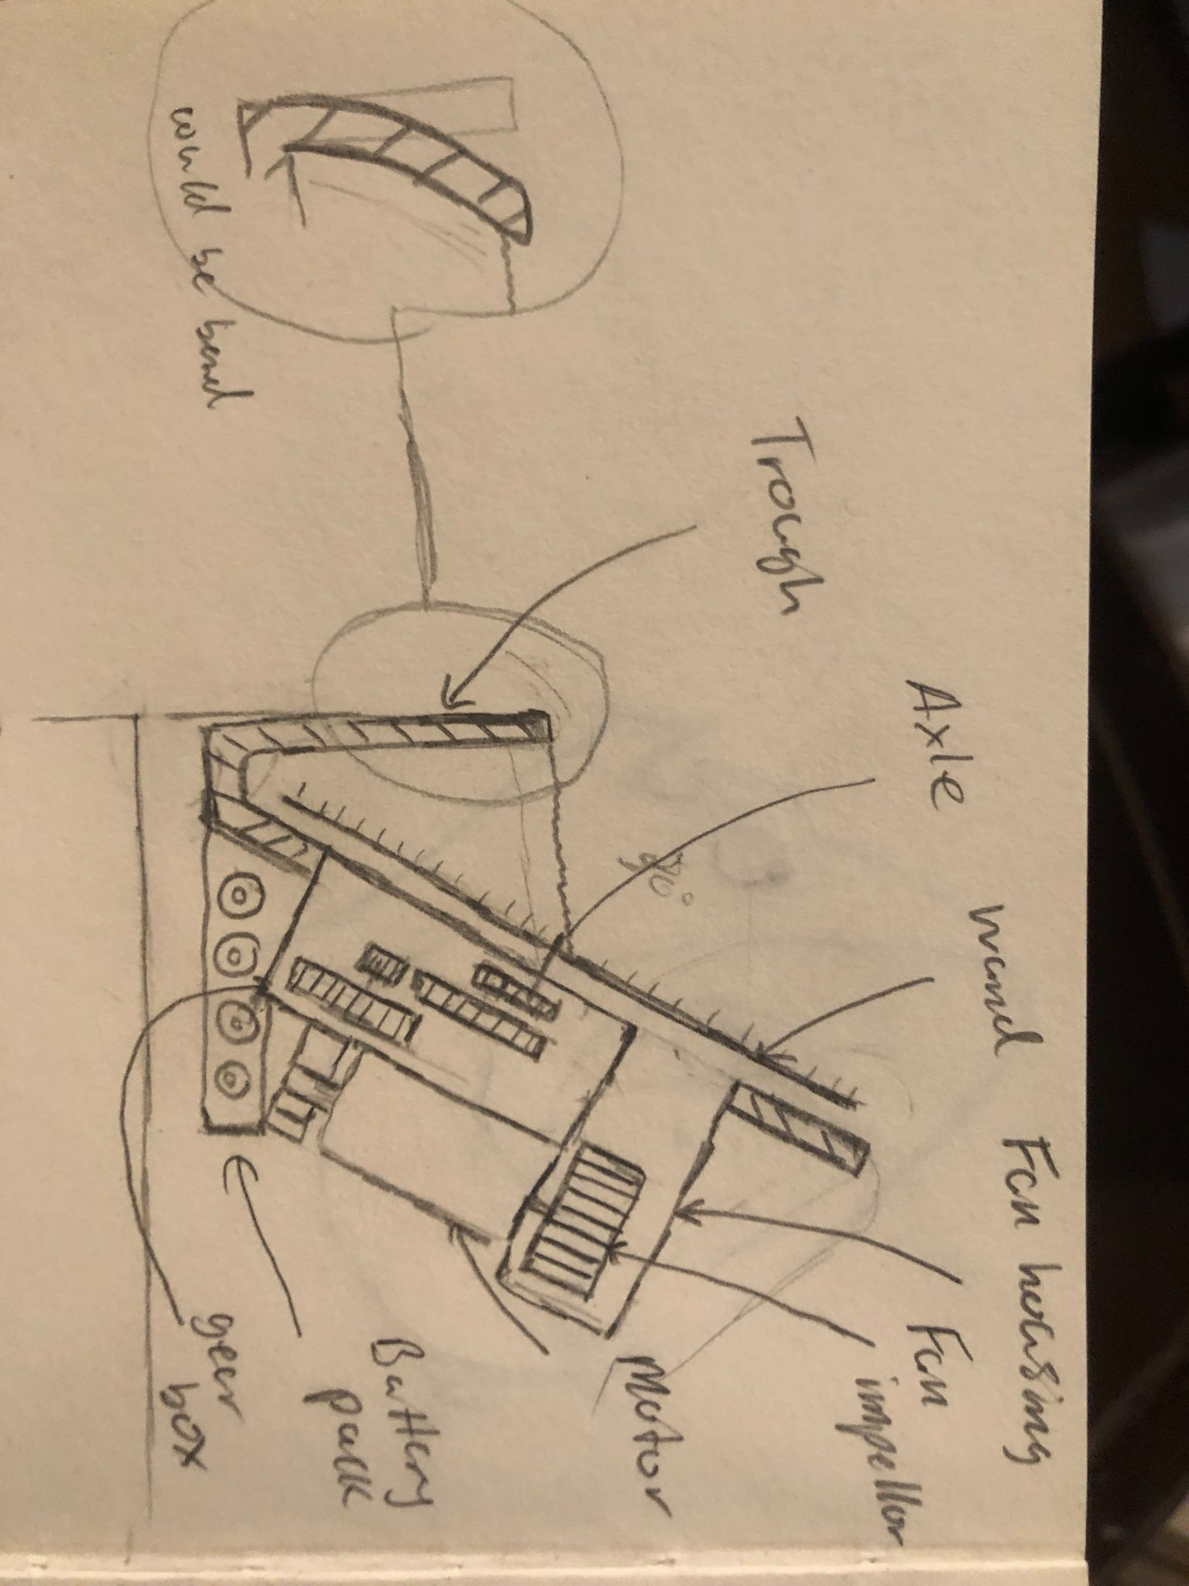

**Figure 10:** Design solidified on after the sketch modeling stage of the design process.

After settling on this basic design, we constructed a testing apparatus that allowed us to change a wide range of variables that we sought to optimize. Our team identified four primary components that would affect our bubble size and designed the apparatus to allow for iteration of those four components. First, the launch angle, defined as the angle at which the wand and fan are tilted, could be adjusted to affect the bubbles’ launch trajectory. Second, the fan speed and therefore the air jet speed was adjustable using a potentiometer wired in series with the fan. Third, the nozzle attached to the fan was replaceable with 3D printed parts, allowing adjustability of the nozzle length and radius. Finally, the entire bubble wand was removable and replaceable, allowing experimentation with different wand designs. Our findings for these specifications are explained in later sections of this report, but once they were solidified we then moved into our third and final design phase.

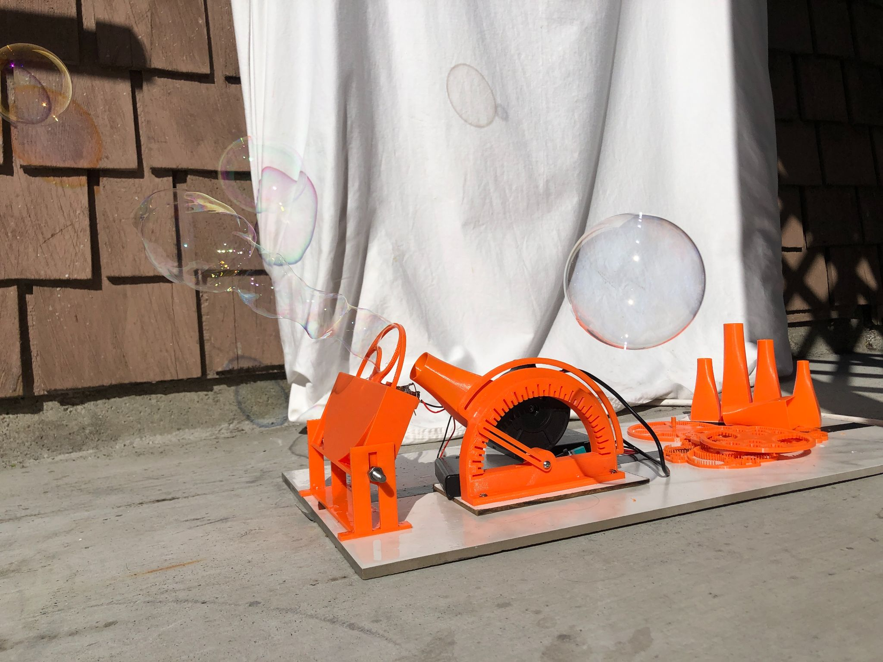

**Figure 11:** Our completely adjustable prototype with some of the replaceable components.

Our final design phase was focused on minituratzing the toy to best fit inside of a custom animal character. By removing the adjustable portions of the prototype and combining it into a single 3D printed piece, the team was able to create a toy that is only 17cm x 12cm x 9cm. This prototype was then installed inside of a custom character using a 3D shell. This shell was developed in conjunction with Move2Play and designed to best appeal to the young kids the toy is designed for. (Katie)

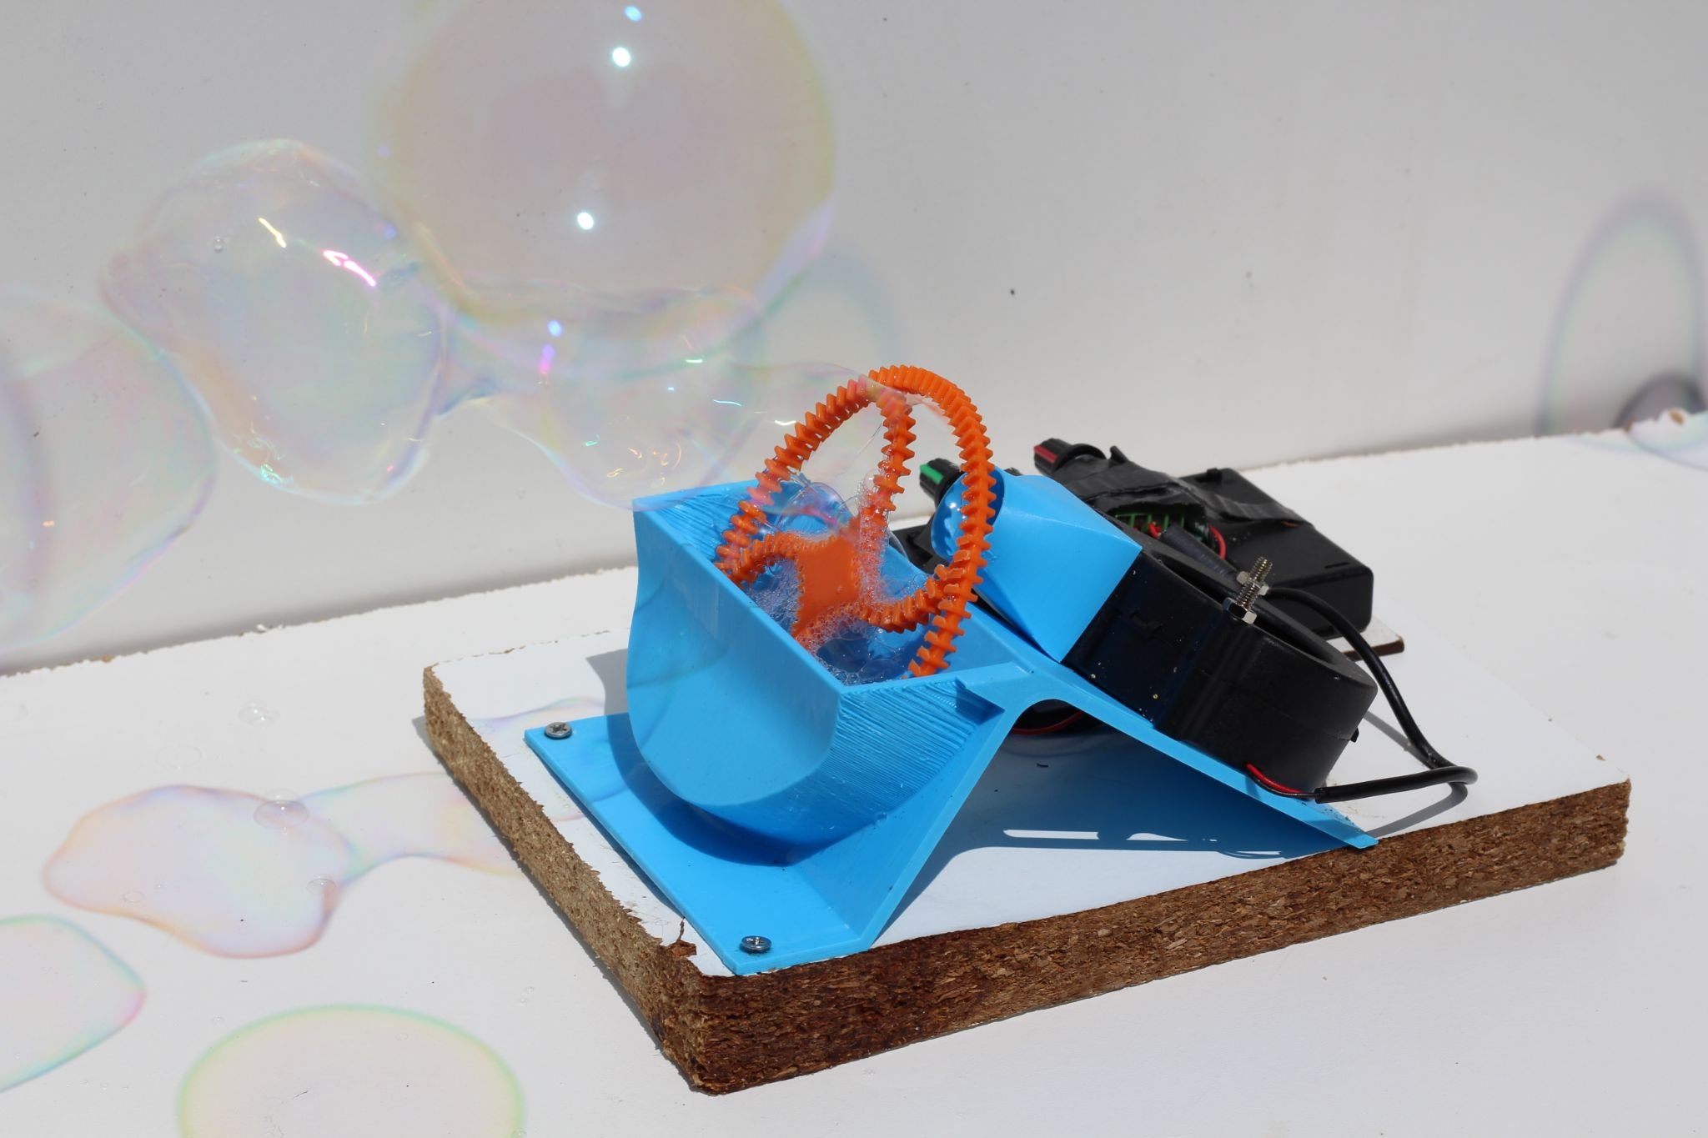

**Figure 12:** The final optimized prototype.

### Optimizing the subcomponents of the machine ensured the largest bubbles.

##### Launch Angle

One of the first requirements we looked to meet was ensuring that bubbles would be able to travel at least one meter in the horizontal x-direction. Consequently, we needed to evaluate the optimal launch angle that would maximize bubble travel distance. Launch angle is defined as the angle relative to the ground in which the exit velocity of the air jet from the nozzle interacts with the soap film on the wand. We determined this launch angle by modeling the projectile motion of a bubble launched in air based on approaches used to model the motion of cough particles in air [18]. Note that in our model we decided to simplify the conditions in 2D plane (considering the x and y axis only).

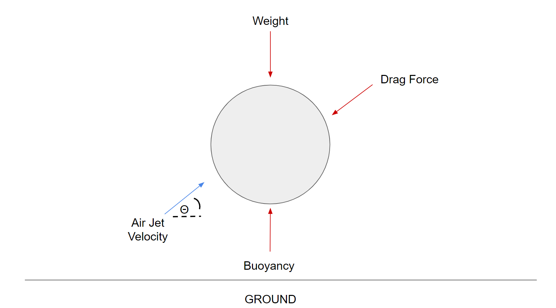

**Figure 13:** Free body diagram of bubble in air; red arrows represent force vectors while the blue arrow represents the air jet velocity leaving the nozzle at an angle, θ

After drawing the free body diagram of a bubble launched in air seen in Figure 13, we derived its equation of motion in a 2D plane (considering the x and y axis only) as the following:

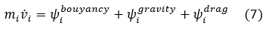

and its components are defined as:

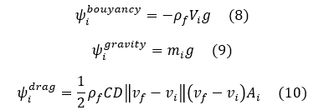

with the following parameters:

* $m_{i}$: mass of the bubble given by $m_{i}=ρ_{i}\frac{4}{3}πR_{i}^{3}$ where $ρ_{i}$ is the density of the bubble’s soap solution and $R_{i}$ is the radius of the bubble
* g: gravity defined as (0, -9.81) m/ $s^{2}$ in the x and y axis respectively
* $ρ_{f}$: density of the fluid medium (air)
* $v_{f}$: velocity of the fluid medium (wind)
* $v_{i}$: velocity of the air jet directed into the soap film where $v_{i}(0)$ is the initial velocity measured at the nozzle exit
* CD: drag coefficient
* $A_{i}$: reference area for a sphere given by $A_{i}=πR_{i}^{2}$
* $V_{i}$: volume of fluid medium (air) given by $V_{i}=\frac{4}{3}πR_{i}^{3}$

Utilizing equations 6 to 9 and their respective parameters, we solved for position, $r_{i}$, computationally with Euler’s Method through an iterative approach on MATLAB. Equation 6 was integrated numerically to obtain velocity:

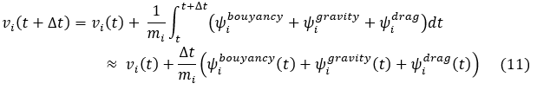

Equation 10 was then integrated again to obtain position:

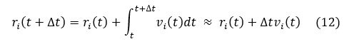

Furthermore, to produce an accurate model, the empirical drag coefficient, CD, was varied with Reynolds number during each iteration in the following piecewise relation [19]:

* For $0<Re≤1, CD =\frac{24}{Re}$
* For $1<Re≤400, CD=\frac{24}{{Re}^{0.646}}$
* For $400<Re≤3×{10}^{5}, CD=0.5$
* For $3×{10}^{5}<Re≤2×{10}^{6}, CD=0.000366{Re}^{0.4275}$
* For $2×{10}^{6}<Re<∞, CD=0.18$
* $Re$: local Reynolds number for a particle given by $Re=\frac{2R_{i}ρ_{f}\left|v_{f}-v_{i}\right|}{μ_{f}}$ where $μ_{f}$ is the fluid medium viscosity

Moving forward, equations 10 and 11 were looped through an array of possible launch angles, θ, where $v_{i}=(v_{i}cosθ,v_{i}sinθ)$, and an array of potential angles, 𝛼, for the direction of the fluid medium velocity (wind) where $v_{f}=(v_{f}cosα, v_{f}sinα_{})$. These simulation parameters are denoted in table 2.

**Table 2:** Simulation parameters

| Variable | Definition | Value |
| --- | --- | --- |
| θ | Launch angle | $0≤θ≤90°$ |
| $v_{i}(0)=(v_{ix}(0),v_{iy}(0))$ | Initial velocity of the bubble | $(7cosθ,7sinθ)$ m/s |
| ⍺ | Fluid medium (wind) direction angle | [0 $°$, 45 $°$, 90 $°$, 180 $°$, 225 $°$, 270 $°$, 315 $°$] |
| $v_{f}=(v_{fx},v_{fy})$ | Fluid medium (wind) velocity | $(5cos⍺,5sin⍺)$ m/s |
| $r_{i}(0)=(r_{ix}(0),r_{iy}(0))$ | Initial position of the bubble | $(0.015, 0)$ m |
| $μ_{f}$ | Viscosity coefficient for fluid medium (air) | $1.8×{10}^{-5}$ Pa-s |
| $ρ_{i}$ | Density of soap solution | $932$ kg/ $m^{3}$ |
| $ρ_{f}$ | Density of fluid medium (air) | $1.225$ kg/ $m^{3}$ |
| $Δt$ | Time-step | ${10}^{-5}$ s |

The results of the simulation generated a plot that displays the relationship between distance traveled by the bubble in the horizontal x-direction and launch angle of air jet velocity. A time-step of $Δt={10}^{-5}$ s was used as smaller step sizes did not produce any significant changes in our results. Additionally, Figure 14 shows the plot for the simulation in a simplified state where $v_{f}=0$ m/s. In this situation, the optimal angle was evaluated to be 44.54° and the maximum x-distance was 4.9 m.

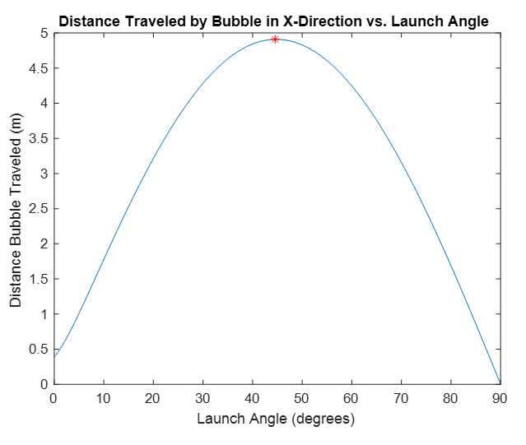

**Figure 14:** Distance traveled in the x-direction vs. launch angle when $v_{f}=0$ m/s

Meanwhile, Figure 14 reveals the outcomes when a fluid medium velocity vector is present for various angle configurations. The magnitude of this fluid medium velocity was estimated to be $\left|v_{f}\right|=5$ m/s based on average wind velocities in Northern California [20]. From, Figure 15, despite the introduction of wind at various angles, the optimal angle was still estimated to be 𝜃 = $44.54°$ for wind direction angles of [0 $°$, 45 $°$, 90 $°$, 270 $°$, 315 $°$] and $θ$ = $43.63°$ for angles of [180 $°$, 225 $°$]. Table 3 shows the maximum x-distance traveled by the bubble at the varying fluid medium direction angles. This makes sense as in an ideal state without drag, the optimal launch angle would be 45 $°$ for achieving maximum range in the x-direction. With air drag the optimal launch angle decreases. Specifically, in the case where the wind direction angle is 180 $°$ or 225 $°$, drag increases in the x-direction due to a counteracting $v_{fx}$ component against the $v_{ix}$ component, which results in a lower launch angle.

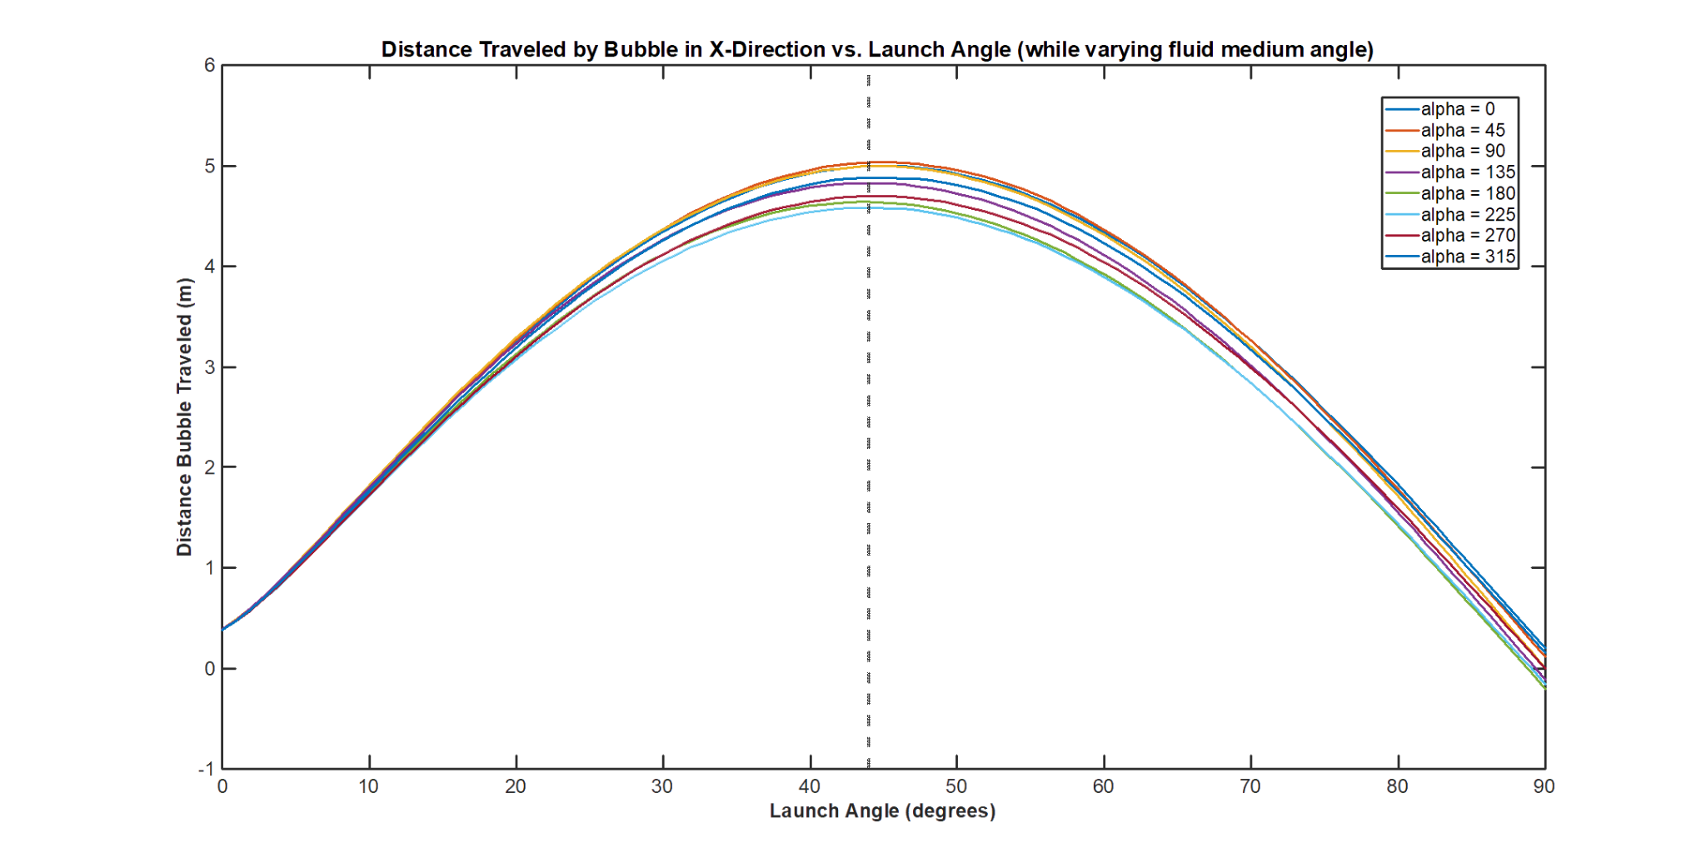

**Figure 15:** Distance traveled in the x-direction vs. launch angle when varying fluid medium direction angles

**Table 3:** Maximum distance traveled in the x-direction for varying fluid medium direction angles

| Fluid Medium (Wind) Direction Angle | Maximum X-Distance Traveled (m) |
| --- | --- |
| $0°$ | 4.9962 |
| $45°$ | 5.0330 |
| $90°$ | 4.9931 |
| $135°$ | 4.8262 |
| $180°$ | 4.6387 |
| $225°$ | 4.5834 |
| $270°$ | 4.6989 |
| $315°$ | 4.8836 |

In our design we decided use a launch angle of 35 $°$ in order to reduce the overall height of the toy, as this is the angle in which the fan must be mounted. Consequently, a launch angle of 35 $°$ results in a travel distance of 4.6 m in the x-distance. Compared to the x-distance estimated for an optimal angle of 44.54°, there is only a 6% decrease in distance traveled by a bubble. Since our design requirement was a 1m travel distance, we are still able to meet this with a launch angle of 35 $°$. (Julie)

##### Fan Design

Designing a custom fan allows us to optimize the fan to achieve more efficient flow, therefore reducing noise and power consumption and drastically lowering the overall cost. The goal of the fan design was to create an impeller and housing volute that can easily be injection molded and operated with a cheap DC motor. The literature on centrifugal fans focused on heavy machinery or automotive applications where a high static pressure load is applied. As such it was challenging to find relevant literature and a number of assumptions are made in this section. Eventually a centrifugal fan comprised of a housing volute and a centrifugal impeller with the following parameters was designed:

$β_{1}:$ Blade inlet angle.

$β_{2}:$ Blade outlet angle.

$d_{1}:$ Inner impeller diameter.

$d_{2}:$ Outer impeller diameter.

$r_{0}$: Outer impeller radius plus small gap.

$u:$ Tangential outlet velocity.

$c:$ Total velocity.

$w:$ Velocity component in line with blade.

$α{}_{}:$ Expansion angle of flow.

$q:$ Mass flow rate through fan.

$b:$ Breadth of the impeller.

$ξ$: Acceleration factor.

A centrifugal fan type was chosen as the fan is both geometrically efficient on space and lends itself well to a motor that provides mechanical work from both ends of it’s drive shaft. The centrifugal fan can be easily mounted to one end of the motor while the other end powers the wand’s gearbox. Eventually the entire toy will be powered by a single motor in this fashion, where the fan will have a curved impeller specifically for our application.

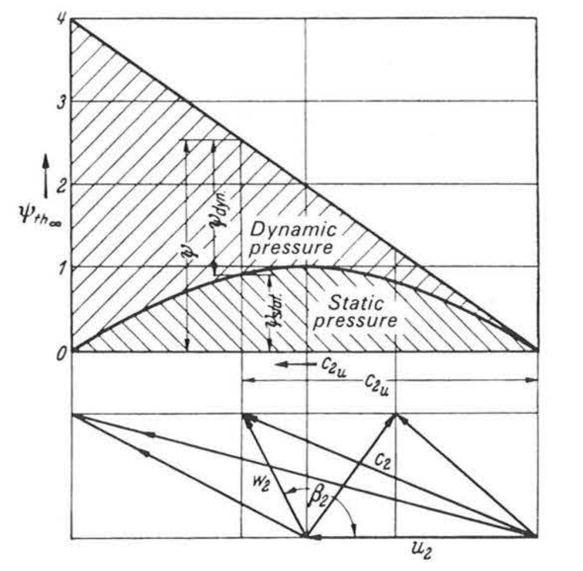

**Figure 16:** Relationship between static and dynamic pressure as the blade outlet angle increases [[21]](https://www.zotero.org/google-docs/?broken=Z3Hz1y)

Forward curved impellers provide flow with a higher ratio of dynamic to static pressure, making them better than other fan types for flows that have a low pressure resistance - such as blowing bubbles. They also have high blade outlet angles greater than 90 degrees. For our application, we chose an angle of 150 degrees based on research [[24]](https://www.zotero.org/google-docs/?broken=Jqh8Pz). Figure 16 demonstrates how the dynamic pressure increases as the blade outlet angle $β_{2}$ increases.

The outer diameter of the impeller was an estimated parameter chosen as a starting point to design the overall fan. This diameter was $d_{2}=40mm$, which is similar to the diameter of the forward curved fan initially purchased for our prototype, but smaller to better fit into the final toy. The inner diameter was chosen by using diameter ratios suggested in research [[24], [28]](https://www.zotero.org/google-docs/?broken=TuVuKR).

The breath of the impeller was chosen by comparing the impeller inlet area to the inlet area of the fan. An acceleration parameter, $ξ$, was used to decelerate the flow as recommended by the literature [[22]](https://www.zotero.org/google-docs/?broken=Nt3Dmg). The breadth $b$ was easily calculated in the following relationship: (Matt)

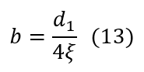

The velocity required to create the dynamic pressure needed to produce bubbles was measured using a hotwire anemometer. This velocity is the total velocity, which was measured as $c= 7.0 ms^{-1}$. The fan operating rotational velocity was chosen to be set at 2000 RPM because it is a reasonable value for the type of motor we were using. With the rotational velocity set, we can calculate the expansion angle of the flow, $α$, using the relationships illustrated in Figure 17 and equations 14 through 16.

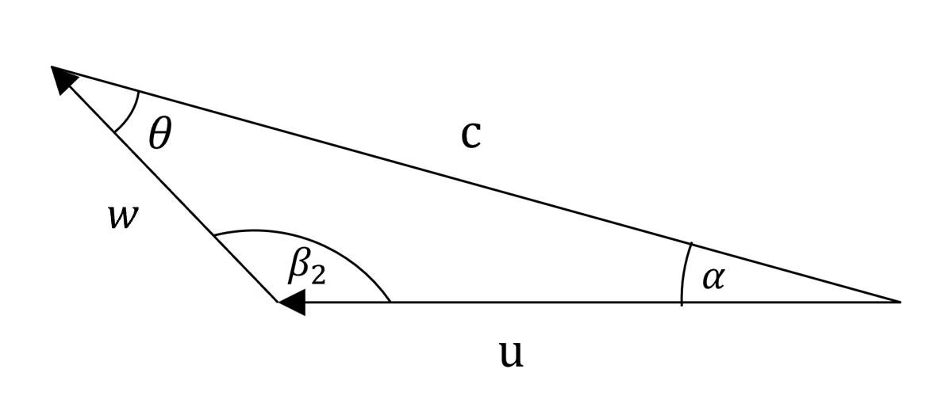

**Figure 17:** Velocity vector components at the outer radius of the impeller.

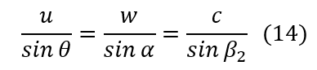

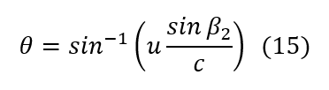

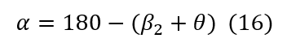

A boundary layer forms on each blade as a result of the fluid air moving relative to the solid blade [23]. Due to the formation of a boundary layer on the front face of the blade, the velocity component of $w$ in the tangential direction is reduced and the expansion angle, $α$, is increased [22] .

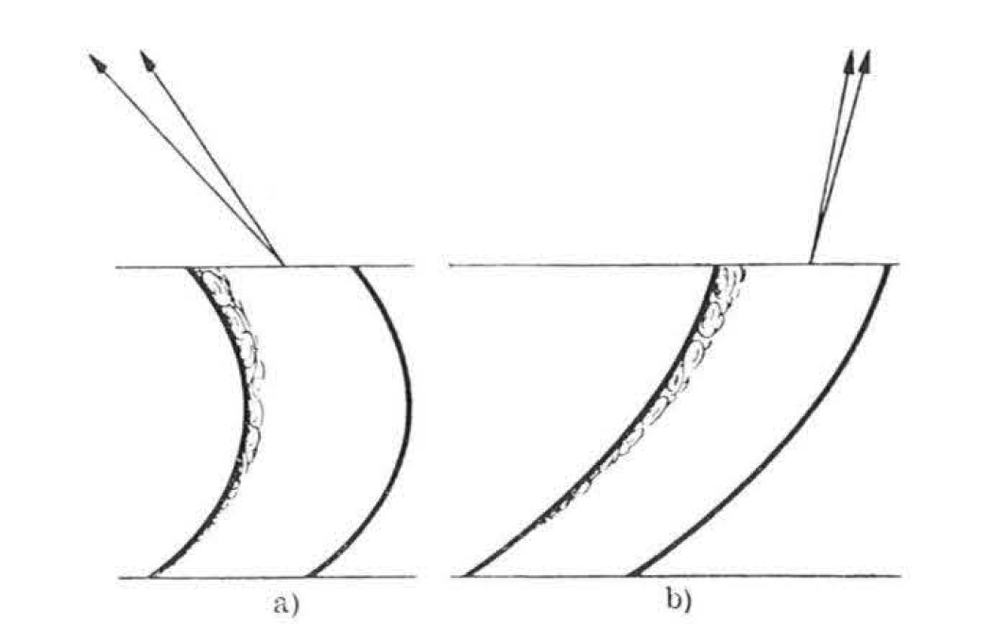

**Figure 18:** Example of expansion angle increase due to boundary layer formation, a) is a forward curved blade [21].

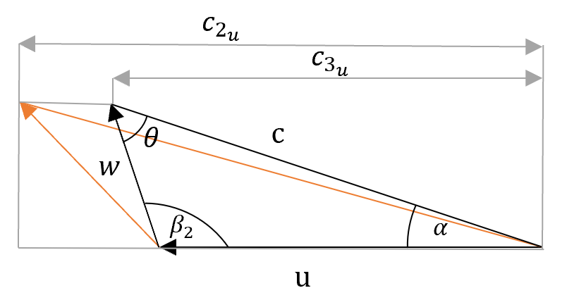

**Figure 19:** Velocity profile accounting for boundary layer, old velocity profile in orange.

The resulting reduction in velocity is described by the velocity coefficient.

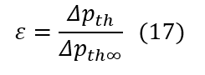

$ε$ is the ratio between the pressure increase due to having a finite number of blades and the pressure increase due to an infinite number of blades. By simplifying we find:

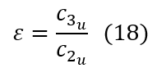

By choosing a velocity factor that is listed in the textbook for forward curved blades, we were able to calculate the expansion angle taking into account boundary layer formation [22].

To determine the impeller blade inner diameter, the ratio between the inner and outer impeller blade coordinates was taken from two sources and each was tested [28], [24]. The results are listed in Table 4 below.

According to the literature the optimal number of blades cannot be determined theoretically. It is also known that increasing the number of blades can improve fan efficiency and the flow coefficient. In a particular study increasing the number of blades from 12 to 18 resulted in an increase of 5% fan efficiency and 10.6% flow coefficient [28]. Therefore the decision was made to use an impeller with the highest number of blades that we thought would still be injection moldable. A 12 blade impeller was decided on. A 20 blade fan was also created to test the increase in flow. The impellers are all similarly light weight therefore to test performance the airflow speed they output with the same motor was recorded.

The expansion angle was used to calculate the shape of the logarithmic spiral volute. From the textbook by Bruno Eck considering the centrifugal impeller as a vortex source and assuming no friction streamlines exiting the source take the shape of a logarithmic spiral.

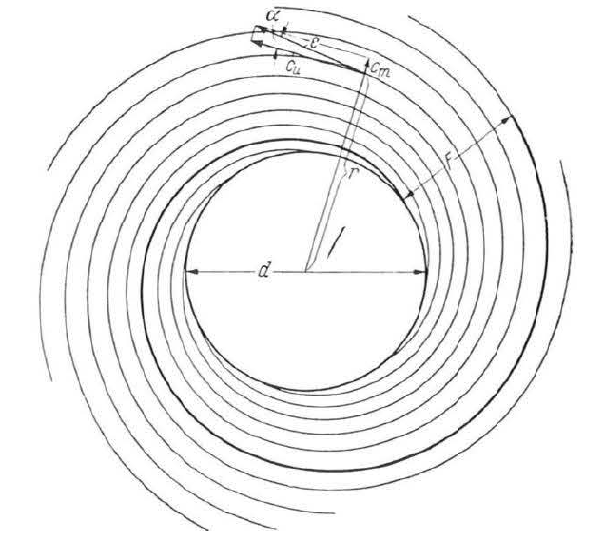

**Figure 20:** Streamlines extending in a logarithmic spiral pattern [22].

By creating a fan casing with parallel walls the flow will be directed with the steadiest transition possible. By using this equation values of the volute wall can be calculated.

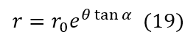

This equation was expressed parametrically as

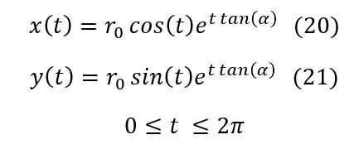

The result is plotted using MATLAB.

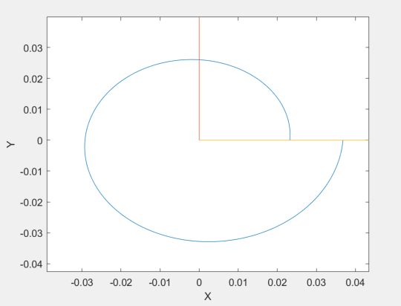

**Figure 21:** Volute parametric equations graphically represented.

The curve was then inputted into a solidworks equation driven curve tool and a volute was modelled.

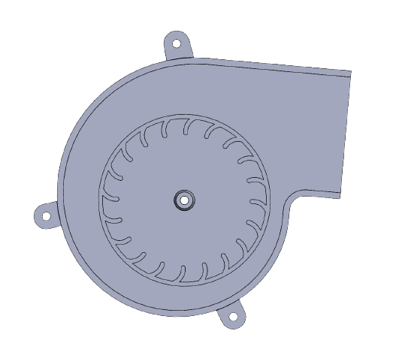

**Figure 22:** Isometric view of 3D modelled volute.

Several different impeller designs were tested. The weight of the impellers is roughly equal and each was tested with a DC motor run at 6V. Therefore as a judge of their performance the resultant maximum flow velocity was measured with a hot wire anemometer. The data is recorded in the table below.

**Table 4:** Impeller testing data

| $β_{2}:$ Outlet angle | $β_{1}:$ inlet angle | Blade number | Diameter ratio | **Velocity m/s** |
| --- | --- | --- | --- | --- |
| 175 | 80 | 20 | 0.8 | 10.0 |
| 150 | 50 | 20 | 0.8 | 10.5 |
| 150 | 50 | 12 | 0.8 | 7.0 |
| 150 | 50 | 12 | 0.5 | 9.2 |
| 150 | 50 | 20 | 0.5 | 10 |

These results show that we can easily exceed the 7.0 m/s flow velocity required to generate bubbles with this fan design. The final impeller will be designed based on how easy the geometry is to injection mold. The data collected will be useful in determining features of the final impeller.

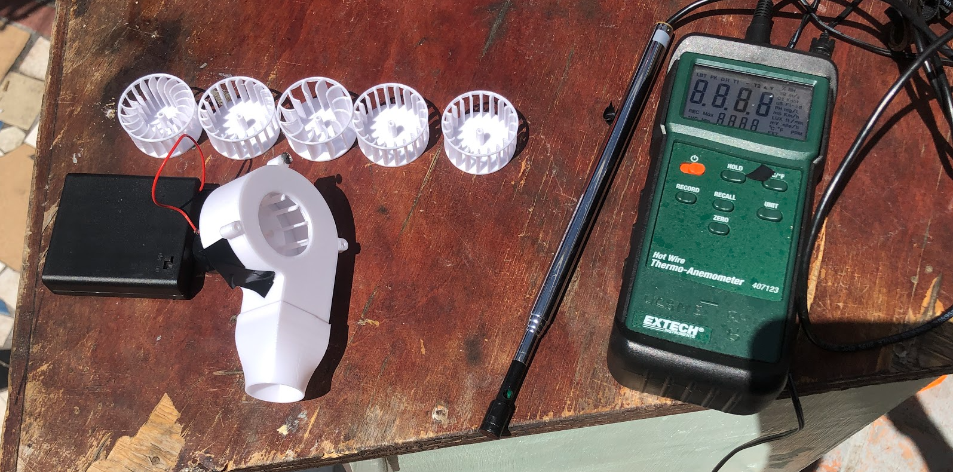

**Figure 23:** A hotwire annonimeter was used to test the different 3D printed impellers.

##### Air Nozzle

To design the contraction nozzle for our prototype we created a simple ‘best guess’ nozzle and measured the velocity required to make a decent bubble. We used that value to calculate the Reynolds number [21]. To determine whether the flow was turbulent or laminar, we calculated the Reynolds number of the flow exiting the nozzle. Density of air is $(ρ)$, velocity of the flow is $(v)$, the characteristic length is equal to the diameter of the nozzle $(L)$ and the dynamic viscosity is $(μ)$. Properties of air for Reynolds number calculation were taken from F. P., & DeWitt, D. P. (2002) and the air was assumed to be at 300K.

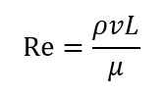

Calculating with $ν= 7.0 ms^{-1}$ (velocity of air) and while creating decent bubbles, we obtain:

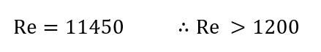

Since the Reynolds number is well above the 0-1200 range we can safely assume that the flow is turbulent [23]. From previous research it is known that the opening angle of an air jet $θ$ is 23.6 degrees when the flow is turbulent [25]. Therefore we decided on the diameter of our nozzle based on a flow with a dispersion angle of 23.6 degrees.

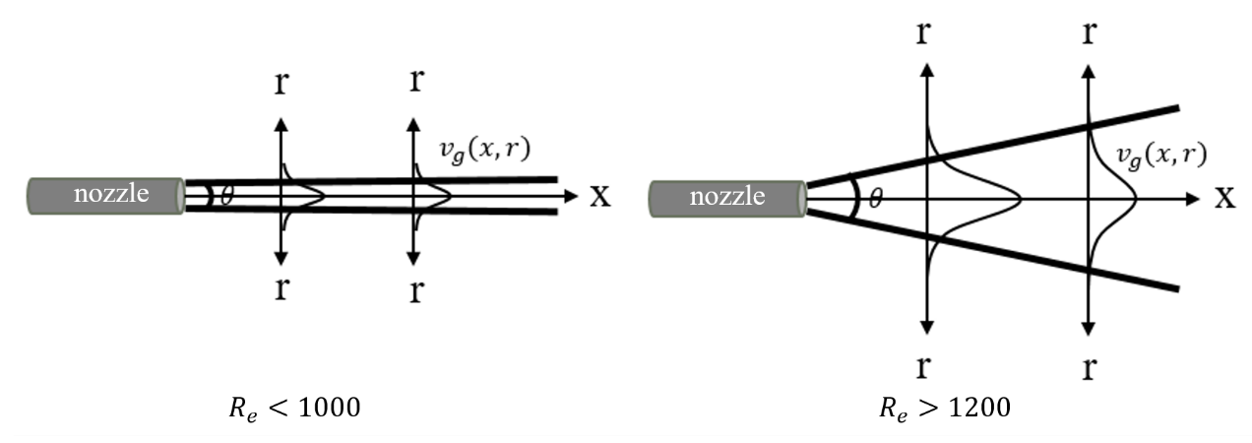

**Figure 24:** Dispersion angle depends on the Reynolds number of the flow $θ= 23.6 degrees$ for $Re >1200$ [2].

We then used a simple geometry to determine what the size of our nozzle should be to generate a flow that would be the same diameter as the wand as it interacts with the wand. With the dispersion angle, $θ$, we set the distance from the nozzle to the wand at $δ= 10mm$, the final diameter of the jet at $D= 37.6 mm$, and $R_{N}$ as the radius of the nozzle.

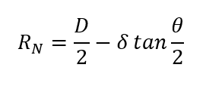

$R_{N} = 16.7mm$

Therefore, we used this as an upper bound for testing nozzle sizes because from our observations, we knew that strain on the edge of a bubble film often causes the film to fail. We knew that the optimal nozzle size would likely be less than $R_{N} = 16.7mm$ because there is a balance between expanding a large area of the film to create a large bubble and straining the edge of the film where failure would occur. We tested $R_{N} = 16.7, 15, 14, 13, 12mm$ and found that 12mm nozzle radius was the most effective at $δ= 10mm$. It is possible that the dispersion angle for our setup is larger than 23.6 degrees based on these results.

Throughout the project we used an available forward curved centrifugal fan as our air flow source. The fan is a Waithai 5V DC fan with an impeller diameter of 55mm, an optimised scroll volute housing and a rectangular exit area of 35mm x 25mm. The fan is capable of achieving a velocity flow of 8.0 m/s at the center of the velocity profile. We needed a way to contract the flow to the shape without major losses in flow rate. The contraction would also help even out the velocity profile and change the shape of the flow into a conical shape rather than a rectangular prism one. We used research from a quick simple wind tunnel design for the contraction section of our nozzle. For contraction contour shape, a third order polynomial was recommended. The constraints on the polynomial were tangent with the inlet,outlet and inflection point at 50% of the contracting section [26]. A contraction semi angle of 12 degrees was recommended [26].

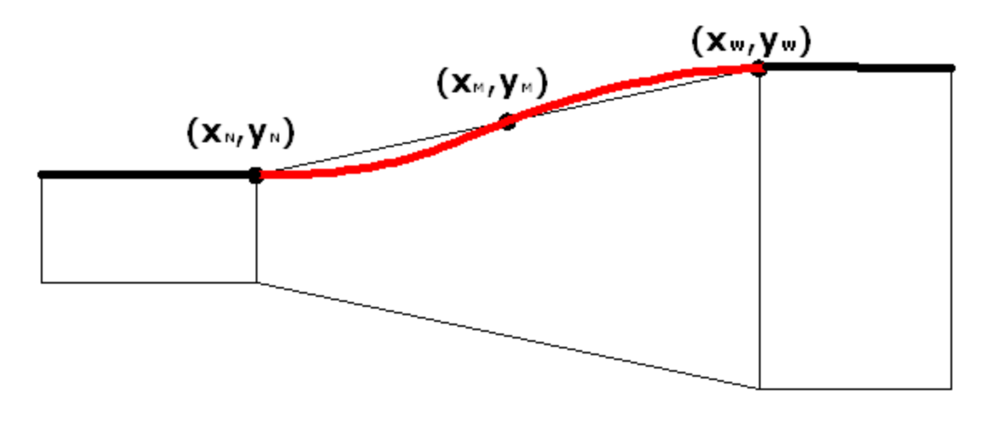

**Figure 25:** Fitted third order polynomial with inflection point at 50% of contraction length [7].

This is the angle to the horizontal and vertical of the contraction slope in both the horizontal and vertical axis. However, having this angle makes our contraction 75mm in length, which is too long for our application. We initially tested a 75mm long nozzle compared to shorter nozzles and found that the efficiency gain was apparent, but not necessary for our application. We then settled with the longest contraction length we could perceivably fit, which was 30mm. To make the exit circular and blended we used the Solidworks loft function. We applied these constraints to the Solidworks model and 3D printed a selection of test nozzles. (Matt)

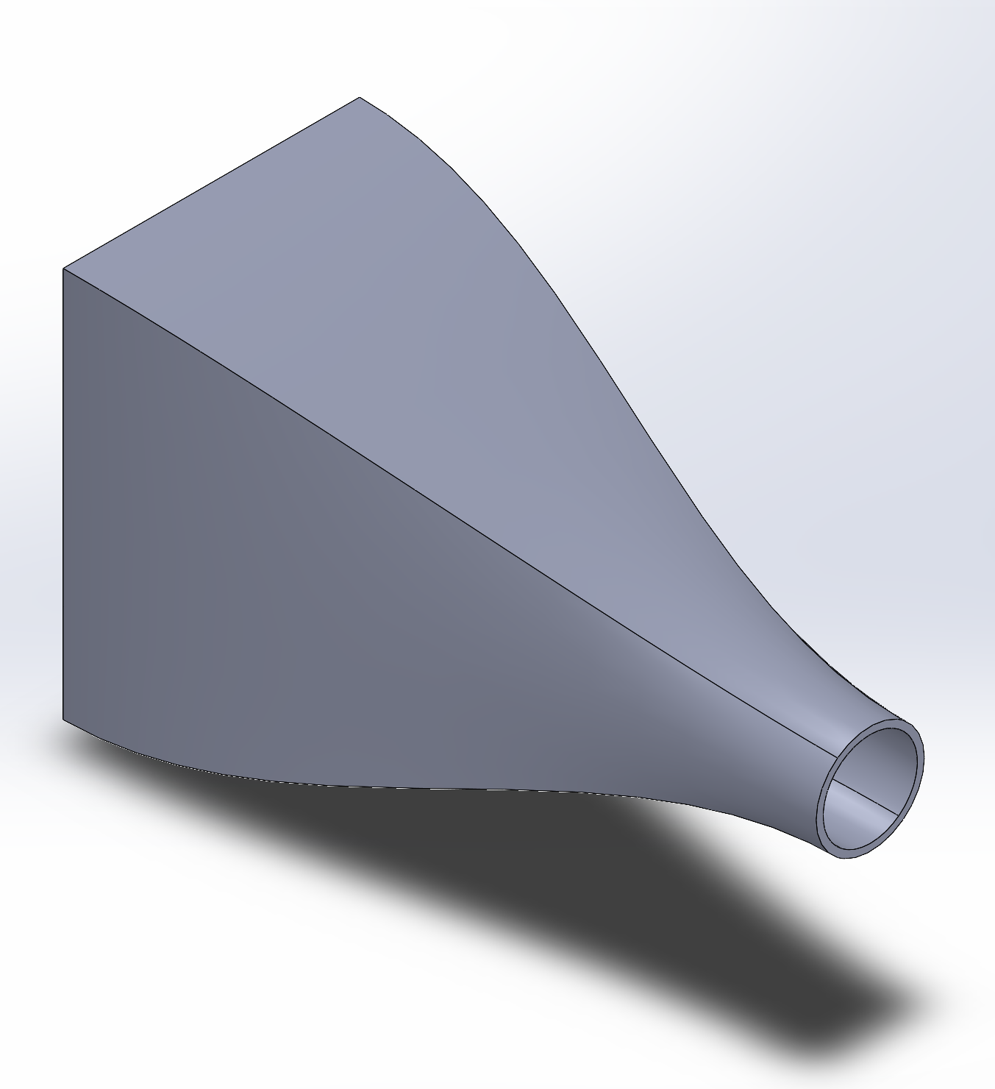

**Figure 26:** The Solidworks model of one of the various test nozzles.

##### Wand Design

Currently there is little research into the design and construction of bubble wands. Most academic studies use a stationary wand constructed from either wire or plastic to maintain a soap film during trials [11], [27].As such, when approaching the challenge of wand design, our team used an experimental approach combined with observations from competing commercial products to develop our design.

Most comercial bubble wands use ridges along the entire length of the wand. These ridges serve as fluid reservoirs, creating more surface area along the wall for soap solution to adhere to. This extra soap solution allows the soap film in each wand segment to last longer, creating a more consistent bubble stream. Research also suggests that this rough surface provides additional contact areas for the soap film, therefore strengthening the soap film, however this has yet to be proven [27]. Our team incorporated these ridges into all of our wand designs to benefit from these properties.

All of our experimental wands were developed using Solidworks and 3D printed with PLA plastic for quick experimentation. Each team member generated two or three wand designs which were tested and compared qualitatively. Wands were designed to fulfill two different goals that the team believed would result in a successful wand. First, wands were designed to maximize soap film area. A large film is required to blow large bubbles, so we wanted to create the largest films we could in the wands while still keeping the wand diameter below 10cm to fit within our outer shell [11]. Additionally, we sought to design wands that created a variety of bubble sizes. Move2Play hypothesized that a variety of bubble sizes would both engage children and present more positively on the Amazon storefront as the large bubbles would appear larger when there are small bubbles to compare them to. Some of the wands designed from this process can be found in Figure 28.

|  |  |  |
| --- | --- | --- |
| (a) | (b) | (c) |

**Figure 27:** Some of the wands designed and tested through this process.

Each wand was run multiple times through the test apparatus and a video of the resulting bubble stream was recorded. These videos were then presented to Move2Play along with the team's notes to select the final wand design. The major key finding from this process was that there was less variation in bubble size than expected. Additionally, most wands that attempted to create size differentials blew multiple bubbles at the same time. These bubbles would immediately conjoin together after their release from the film. They would then often stick themselves to the test apparatus creating bubble froth that prevented future bubbles from forming as seen in Figure 28.

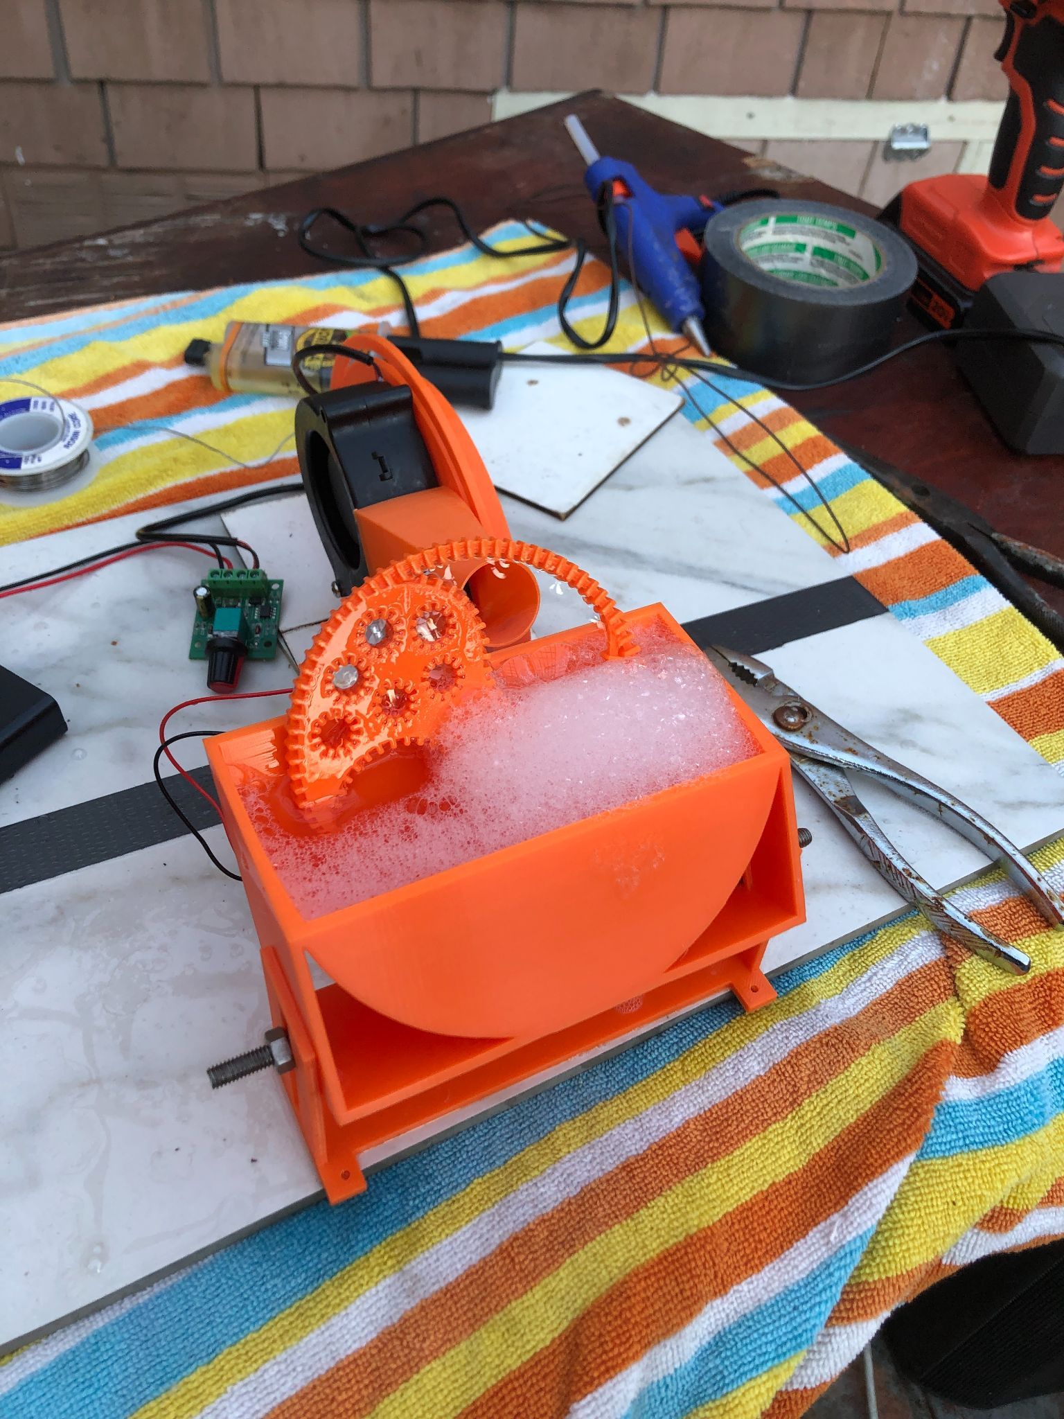

**Figure 28:** An example of bubble froth

Because of this phenomenon, we selected one of the simpler designs, the yin-yang inspired wand, as the final design. This wand maximized soap film size and ensured that only one bubble was forming at a time. While this wand created fewer overall bubbles than other wands, the bubbles were both larger and more consistent. (Katie)

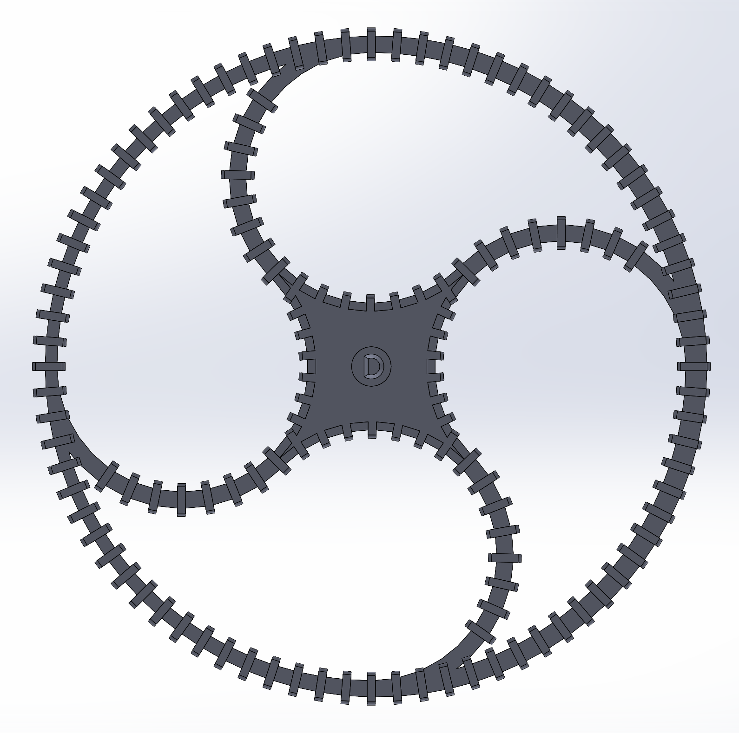

**Figure 29:** The final Yin Yang wand

## Results: Our bubbles are bigger than others.

With the prototype constructed and optimized, we then proceeded to design a testing methodology to validate that our bubbles are larger than those produced by other toys on the market. We chose to compare our machine to the WisToyz and KidzLane bubble machines because they are the top sellers on Amazon marketplace and use mechanisms similar to our design. Each toy was run for roughly 30 seconds twice and the resulting bubble stream was filmed using a Canon T5I camera with a 15mm F/1.8 lens. These videos were then sliced into still images designed to capture as many individual bubbles as possible. The diameters of the bubbles were then measured in pixels and converted into centimeters using a calibration meter stick. The resulting bubble diameters were analyzed and the results can be seen in Figure 29 and Table 5.

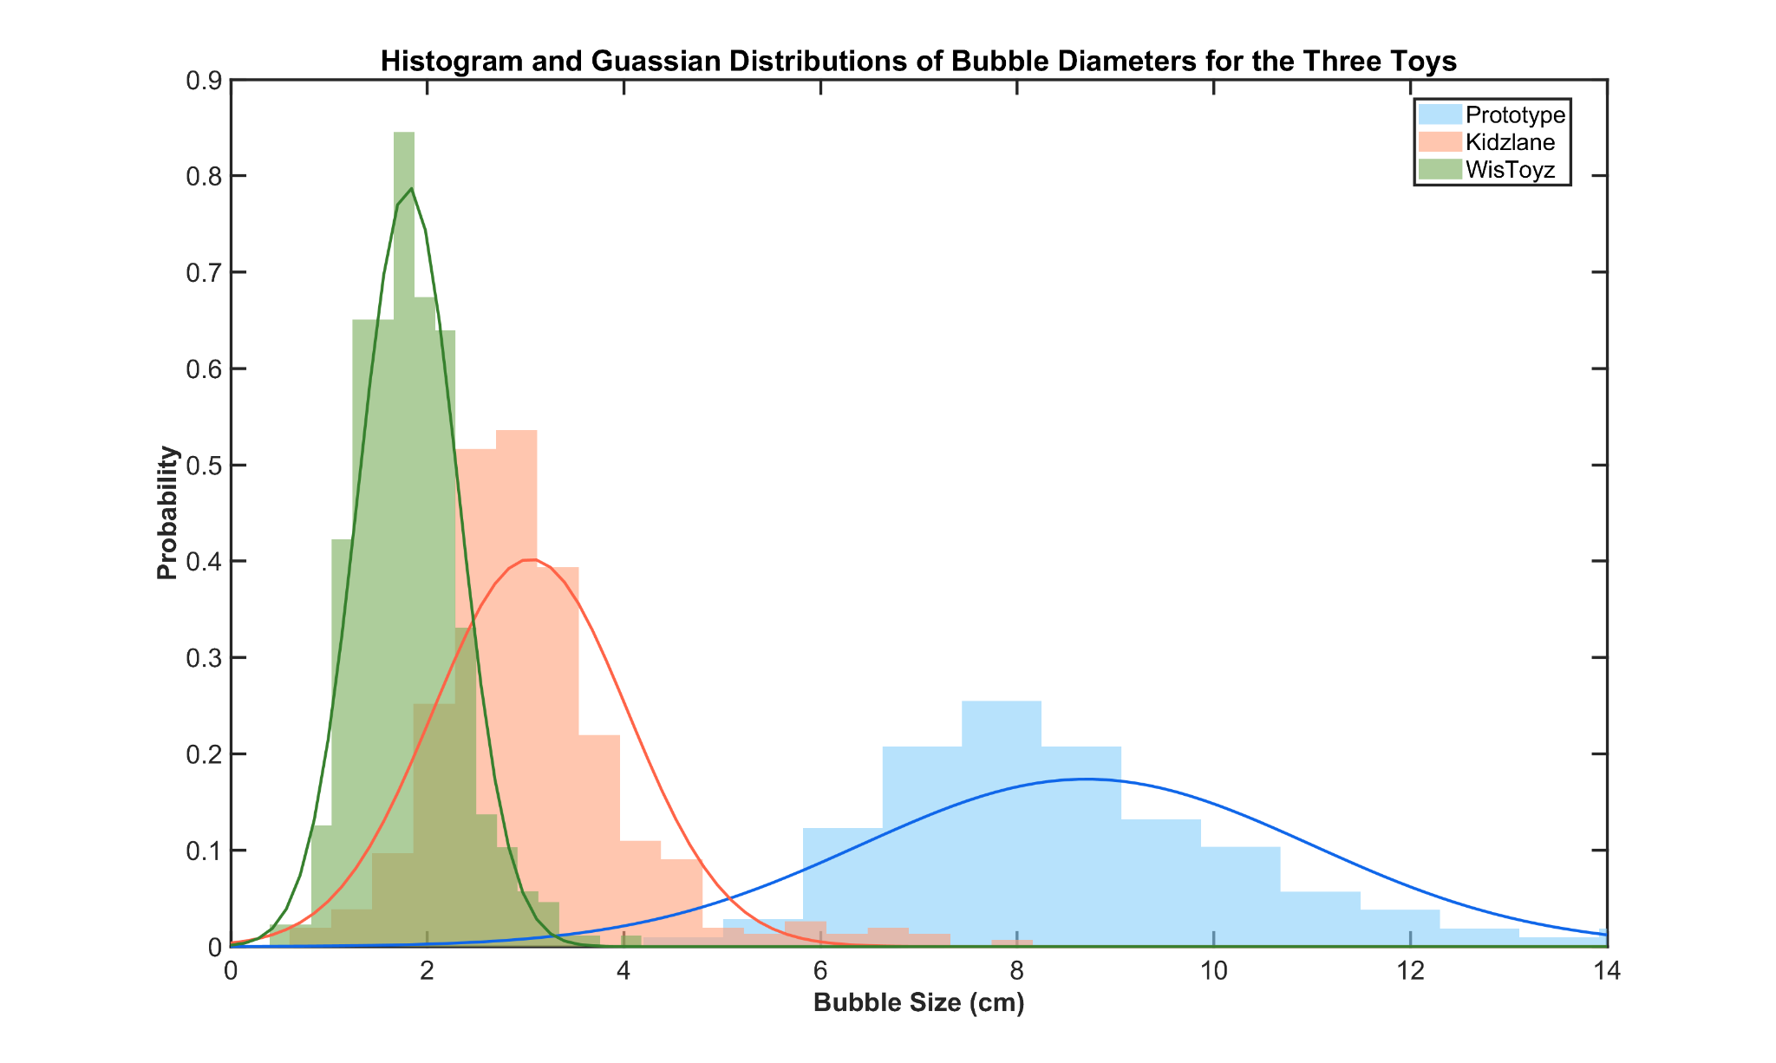

**Figure 30:** Histogram of the three bubble toys. Gaussian distributions of the means are overlaid.

**Table 5:** Means and standard deviations for all three bubble toys

|  | **Prototype** | **KidzLane** | **WisToyz** |
| --- | --- | --- | --- |
| **Mean Bubble Diameter (cm)** | 8.70 | 3.05 | 1.81 |
| **Standard Deviation of Bubble Diameter** | 2.30 | 0.99 | 0.51 |

These results confirm that the new prototype’s mechanism creates bubbles that are statistically significantly larger than the KidzLane and WisToyz toys. It also highlights that our bubbles experience a higher variance in bubble diameter as seen by the higher standard deviation. Move2Play prefers this higher variance because they expect that the dynamic changes in bubble size will result in higher child engagement with the toy.

While these results are significant, there are limitations to this testing method. First, wind speed can have a noticeable effect on bubble formation and while trials occurred sequentially, the location of the test was prone to wind gusts that affected the trials. Additionally, the image processing software that was intended to be used to measure bubble diameters struggled to recognize the transparent bubbles, so diameter measurements were taken by hand rather than computationally. As such, the sample size for these tests is relatively small compared to the 10 minute run time we expect our toy to experience. Even with these complications in mind, our team is confident that our bubbles easily surpass our 7.5 cm diameter design requirement. (Katie)

## Playtesting reveals that kids prefer our product.

A major part of whether the finished product will actually be successful is whether kids actually like the bubbles our toy produces. While the enjoyment gained from the toy is not a direct determining factor in whether someone will choose to buy the product on amazon, toy enjoyment generally converts to positive reviews which in the long run increases sales. Therefore, our goal was to test prototypes with kids as early as possible to ensure we are headed in the right direction. The target user was determined to be children of the age 3-5 years old as this is the age at which kids generally show the most interest in bubbles. At this age kids have enough motor control to chase and pop bubbles but little life experience making physical phenomena such as bubbles inexplicable and wondrous.

As early as phase 2 of our design process we provided our toy to potential users and developed a user testing scheme to judge performance. The main metric tested was the amount of time children spent engaged with the toy. We compared the engagement to that of the KidzLane bubble machine. We asked the parents of our user testers to introduce the toys on separate days and measure the time kids wanted to spend playing with each one. Although this is a process that is fraught with bias we hoped that it would give us some insight into how kids might find our toy.

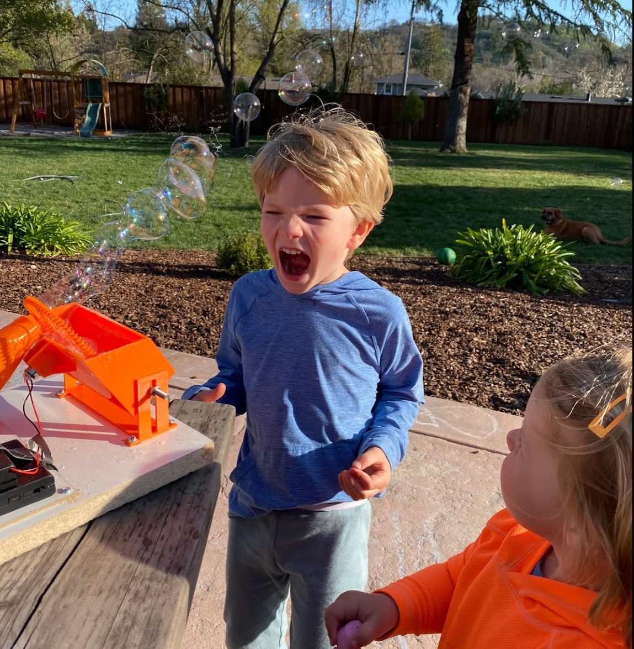

**Figure 31:** Users testing our earliest prototype. Photos provided by Move2Play and displayed with express permission of user testers caregivers.

On the initial round of testing the result was that kids stayed engaged for ~25 minutes each play session with our prototype compared to ~20mins with the KidzLane toy. Qualitatively kids that tested both toys expressed a preference for our toy. One tester stated “I just want big bubbles”. We tested multiple iterations of our prototype with certain kids. After one round a parent commented that their child would leave the machine on and use all the bubble liquid playing for an hour or more if they were allowed to. Feedback was that the kids were excited to have our toy to play with again and asked to use it once testing was over and the toy was returned to us. (Matt)

## Our toy is proven to meet our design requirements.

In retrospect, by understanding the principles of bubble formation, we were able to design a toy that performed reliably and repeatedly. One of the most important requirements was achieving bubble diameters greater than 7.5 cm as this would differentiate our toy from others on the current market. Through optimizing the wand, fan, and nozzle design, we produced bubbles 16% larger than the requirement. Our bubbles were measured to have an average diameter of 8.7 cm, which is 2.85 and 4.8 times larger than the average diameter of bubbles produced by KidzLane and WizToyz products. Additionally, we modeled the projectile motion of a bubble launched in air to obtain an ideal launch angle that would maximize the bubble distance traveled in the x-direction. To reduce the overall height of the toy, we compromised on a 35° degree launch angle. At this angle, the travel distance was estimated to be 4.6 m, which exceeds our initial design requirement of 1 m. After manufacturing our prototype, the device successfully ran on 3 AA batteries for a run time of at least ~20 minutes during playtesting.

Moving forward, Move2Play will need to work with manufacturing to modify prototype components for injection molding and design a gearbox for actuating the wand and fan. We hope to see a production ready version of this prototype on the market by Winter of 2021. (Julie et al.)

# Bibliography

[1] “Jean Siméon Chardin | Soap Bubbles,” *The Metropolitan Museum of Art*. https://www.metmuseum.org/art/collection/search/435888 (accessed Apr. 11, 2021).

[2] A. Lawrence and D. E. Choe, “Mobile Media and Young Children’s Cognitive Skills: A Review,” *Acad. Pediatr.*, vol. 0, no. 0, Jan. 2021, doi: 10.1016/j.acap.2021.01.007.

[3] W. Chen and J. L. Adler, “Assessment of Screen Exposure in Young Children, 1997 to 2014,” *JAMA Pediatr.*, vol. 173, no. 4, pp. 391–393, Apr. 2019, doi: 10.1001/jamapediatrics.2018.5546.

[4] “Effects of screentime on the health and well-being of children and adolescents: a systematic review of reviews | BMJ Open.” https://bmjopen.bmj.com/content/9/1/e023191 (accessed Mar. 14, 2021).

[5] “Move2Play.” https://www.move2play.com/pages/home (accessed Mar. 14, 2021).

[6] J. Colantonio and E. Bonawitz, “Awesome play: Awe increases preschooler’s exploration and discovery,” Open Science Framework, preprint, May 2018. doi: 10.31219/osf.io/pjhrq.

[7] P. Valdesolo, A. Shtulman, and A. Baron, “Science Is Awe-Some: The Emotional Antecedents of Science Learning,” *Emot. Rev.*, vol. 9, Jun. 2017, doi: 10.1177/1754073916673212.

[8] “Everything You Need to Sell on Amazon and More,” *Helium 10*. https://www.helium10.com/ (accessed Mar. 14, 2021).

[9] “Amazon.com: WisToyz Bubble Machine Bubble Blower Hippo Bubble Toys with Bubble Solution Cute Bubble Machine for Kids Toddler Toys Auto Bubble Maker 500+ Bubbles Per Minute, Easy to Use 2 x AA Batteries Needed: Toys & Games.” https://www.amazon.com/WisToyz-Machine-Toddlers-Automatic-Batteries/dp/B08F7TS2TJ (accessed Mar. 14, 2021).

[10] G. Cui, H.-K. Lui, and X. Guo, “The Effect of Online Consumer Reviews on New Product Sales,” *Int. J. Electron. Commer.*, vol. 17, pp. 39–58, Oct. 2012, doi: 10.2307/41739503.

[11] J. M. Davidson, “Experimental study on the effect of air flow on soap bubble formation,” p. 57.

[12] “The Science of Soap Films and Soap Bubbles [Cyril Isenberg] | Surface Tension | Area,” *Scribd*. https://www.scribd.com/doc/78830427/The-Science-of-Soap-Films-and-Soap-Bubbles-Cyril-Isenberg (accessed Apr. 11, 2021).

[13] P.-G. de Gennes, F. Brochard-Wyart, and D. Quere, *Capillarity and Wetting Phenomena: Drops, Bubbles, Pearls, Waves*. New York: Springer-Verlag, 2004.

[14] “Rayleigh-Plateau Instability (Pi Theorem) - YouTube.” https://www.youtube.com/watch?v=DJw_D8HUuOw (accessed Apr. 11, 2021).

[15] M. C. Potter, D. C. Wiggert, and B. H. Ramadan, *Mechanics of Fluids*, 004 edition. Cengage Learning, 2011.

[16] “Bubbles | Causes of Color.” http://www.webexhibits.org/causesofcolor/15E.html (accessed Apr. 11, 2021).

[17] “Color and Film Thickness,” *Soap Bubble Wiki*. https://soapbubble.fandom.com/wiki/Color_and_Film_Thickness (accessed Apr. 11, 2021).

[18] T. I. Zohdi, “Modeling and simulation of the infection zone from a cough,” *Comput. Mech.*, vol. 66, no. 4, pp. 1025–1034, Oct. 2020, doi: 10.1007/s00466-020-01875-5.

[19] C.-Y. Chow, *An Introduction to Computational Fluid Mechanics*, 0 edition. Boulder, Colo.: Seminole Pub Co, 1983.

[20] “Average Wind Speeds - Map Viewer | NOAA Climate.gov.” https://www.climate.gov/maps-data/dataset/average-wind-speeds-map-viewer (accessed Apr. 11, 2021).

[21] F. P. Incropera, F. P. Incropera, D. P. DeWitt, T. L. Bergman, and A. S. Lavine, *Fundamentals of Heat and Mass Transfer*. Wiley, 2007.

[22] B. Eck, *Fans; design and operation of centrifugal, axial-flow, and cross-flow fans*, 1st English ed edition. Oxford, New York: Pergamon Press, 1973.

[23] F. White, *Fluid Mechanics*, 8th edition. New York, NY: McGraw-Hill Education, 2015.

[24] K.-Y. Kim and S.-J. Seo, “Shape Optimization of Forward-Curved-Blade Centrifugal Fan with Navier-Stokes Analysis,” *J. Fluids Eng.*, vol. 126, no. 5, pp. 735–742, Dec. 2004, doi: 10.1115/1.1792256.

[25] M. Zhou, M. Li, Z. Chen, J. Han, and D. Liu, “Formation of soap bubbles by gas jet,” *Appl. Phys. Lett.*, vol. 111, no. 24, p. 241604, Dec. 2017, doi: 10.1063/1.5000439.

[26] M. A. G. Hernández, A. I. M. López, A. A. Jarzabek, J. M. P. Perales, Y. Wu, and S. Xiaoxiao, “Design Methodology for a Quick and Low-Cost Wind Tunnel,” *Wind Tunn. Des. Their Diverse Eng. Appl.*, Mar. 2013, doi: 10.5772/54169.

[27] C. A. E. Hamlett *et al.*, “Blowing big bubbles,” *Soft Matter*, vol. 17, no. 9, pp. 2404–2409, Mar. 2021, doi: 10.1039/D0SM01893G.

[28] Singh, O. P., Khilwani, R., Sreenivasulu, T., & Kannan, M. (2011). Parametric study of centrifugal fan performance: experiments and numerical simulation. *International Journal of Advances in Engineering & Technology*, *1*(2), 33.